**I. Narrative**

**A. Executive Summary**

The Barangay Project is a Web-based application that can store, receive, accept and process data of the user. These features fit perfectly to help citizens of the Philippines to easily experience the services being offered by the government and making use of the technology to their own advantage. With “helping Filipinos” in mind, developers were asked to create a system that helps the lowest form of the government which is the barangay. Every barangay in the Philippines provides services to their constituents. But with the Barangay Project, it bring “providing of services” to a whole new level. Government services that the barangay provides will be available online. From requesting an ID, clearance, business permit, submitting documents, to postings of current news, events and happenings in the barangay. And of course the system’s security will always be a top priority. That is why registration and approval are a critical part of the systems features and a requirement in order for users to actually use the system.

**B. Introduction**

**1. Client’s Profile**

*ABNER A. ARRIETA JR.*

Twenty five years of relevant work experience in Enterprise Architecture, Process Consulting, Customer Lifecycle Management, Business Process Throughput Analysis, Business Area Analysis and Optimization, Enterprise Business Intelligence and Knowledge Management, Business Development and Information Technology Industry from Systems Administration to Product Marketing and Product Sales Management to Process Consultancy.  Abner currently holds the position of Business Development Director for the Philippines of Intense Technologies Limited.

Abner previously held the positions of Director for Strategic Initiatives - eBiZolution, Inc., Senior Manager - Consulting Group – StrategicSynergy, Inc., Managing Director for Business Process Management Consulting and Solutions – CoreSynergy Inc., Solutions Director – Systems Standards Inc. and previously was the eServer Manager of IBM Philippines for the IBM managed accounts.

Experienced in Consultative Selling and has focus on developing and implementing a business plan, which utilizes all channels and resources to maximize solution presence in customer accounts.  Abner has work experience in providing consultancy in IT optimization / server and storage consolidation.  Abner is a creative problem solver with an ability to drive revenue growth, resolve conflict, improve morale and exceed profit goals.  Abner has solid background in planning and executing sales and marketing plans.  Abner is a hands-on manager with highly developed negotiation skills and experience cultivating strategic business partnerships.

Abner has proven the ability to recognize and capitalize market trends and assume bottom-line responsibility for sales forecasts, strategic planning, market research and forecasting and is equally strong in budgeting and financial management.

**2. Project Organization**

**a. Project Team**

|  |  |
| --- | --- |
|  |  |
| Name | **Position** |
| Kamila Lagman | Project Manager |
| David Warren Arcellana | Project Developer |
| Jhonel Deluna | Project Developer |
| Daren Mar Cabral | Project Developer |
| Ansel Christian Sevilla | Project Developer |

**b. Project Professor**

Mr. Manuel Sanchez

**c. Project Adviser**

- Mr. Allan Sta. Cruz  
 - Mr. JV Roig   
 - Ms. Kris Rebolledo  
 - Mr. John Patrick Bejar

**3. Client’s Mission and Objectives**

The client’s mission in this project aims for a better Philippines and how this project can impact the lives of every Filipino by making use of the latest and existing technologies to reach out for people and providing them services offered by the government that they needed. With the client’s vision and the developer team’s background and knowledge in computer science and information technology, the Barangay Project was made possible. The Barangay Project provides easy access to information and services that are being offered by every barangay anytime anywhere. The Project is a web-based application that can store, receive, accept and process data of every citizen who wishes to make use of its service and at the same time inform the citizens by providing educational learning and latest happenings in their respective barangays. This Project is just a small part of a much bigger picture and a bigger project in progress in which every citizen in the Philippines gets to have their own personal identification recorded and stored.

**4. Project Objectives**

The system’s objectives are to create organized and secured information details for the barangay citizen to provide fast and accurate transactions, and help lessen complications in the manual processing such as information redundancy caused by repetitive registration and avoid missing data thus leading to successful document processes. The system also aims to educate citizens by providing them with appropriate content of information and giving them easy access to this information.

**5. Purpose of the Project**

The purpose of the Barangay System is to be as efficient as possible. It will turn the old system into an automated system. All the basic services of the barangay will be automated and all the data will be more secured and authentic. The objective of the system is to ensure efficiency and security. The application will be handled by the barangay officials and it will used by the masses. In the case of the transaction that involves payment, the citizen must go to the barangay office and pay manually. The main process of the system is to collect information and data from citizens who will register and the system automatically displays the standard format of registration form. The bulletin’s role is to inform citizens are the events, news, tips, and updates of the specific barangay. Also, the system has the capability to give information in health, education and documents.

**6. Rationale of the Project**

**a. Current Process of the Flow** 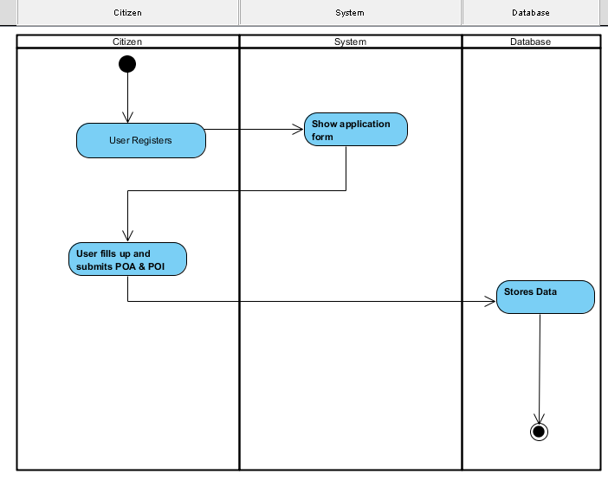

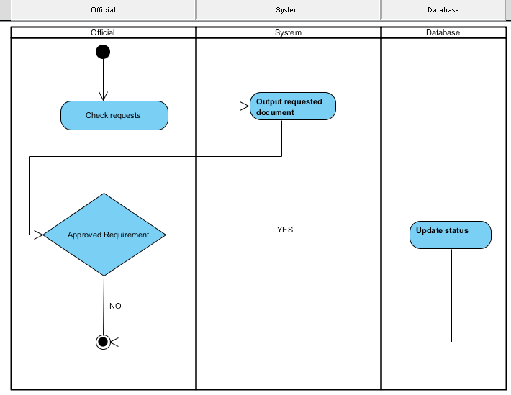

**b. User Information Needs**

The user information needs registering information to the system, softcopies of Proof of Identity or Address. Examples are Meralco Bill, Maynilad Bill or Valid ID as long as there is a legit address of the citizen.

**c. How the Information is being processed**

The information is processed by adding information of the citizen in the system and also the citizen can update his/her profile or make changes. The system displays the update information of the citizen.

**C. System Features and Function**

**1. Software Environment**

**a. Programming Languages**

The system makes use of the HTML and CSS for the interface and design of the system and for the main function and connecting database it used PHP and JavaScript.

**b. Specific Software**

In order for the system to create, it uses a COBALT framework, it is the code generator used to create most function of the system and also creates the database. It used Sublime and Notepad++ for the text editor. As for the localhost of the system it uses XAMPP and WAMP for the PHPMyAdmin and also a web browser for the user interface. The XAMPP is also used for the connection for the mobile in order for the system to be resized in the mobile (it is compatible in any mobile device). In editing the photos in contact and about page, it used Adobe Photoshop CS6.

**c. Web Server Application**

The system used WampServer 2.5 and XAMPP (MySQL and PHP). Is a web  
 development platform.

**d. Operating System**

The barangay system is compatible to any operating system like Windows, Linux and Macintosh based on the fact that the system can run to any web browser.

**e. Other Software**

**2. Hardware Environment**

The recommended minimum requirements are 256MB of RAM for a single-computer website and 85MB of storage with as little as 48MB of RAM.

**3. Networking and Security**

**a. Security**

One of the security in the database is that the XAMPP phpmyadmin can have a username and password before entering the database.

**b. Server**

The system used WampServer 2.5 (MySQL and PHP) is a web development platform used to create dynamic web applications with MySQL and PHP.

**4. Application System Modules**

**a. Citizen Registers.**  
 The citizen must first register to the system in order to use the main function of the system like requesting basic barangay documents.  
 **b. Request Document**  
 The citizen can request basic barangay documents like barangay ID, barangay clearance, and business permit etc.   
 **c. Update Bulletin**  
 The system has a bulletin about the news, updates and events in the barangay.

**II. System Diagrams and Screenshots**

**A. Data Flow Diagram**

**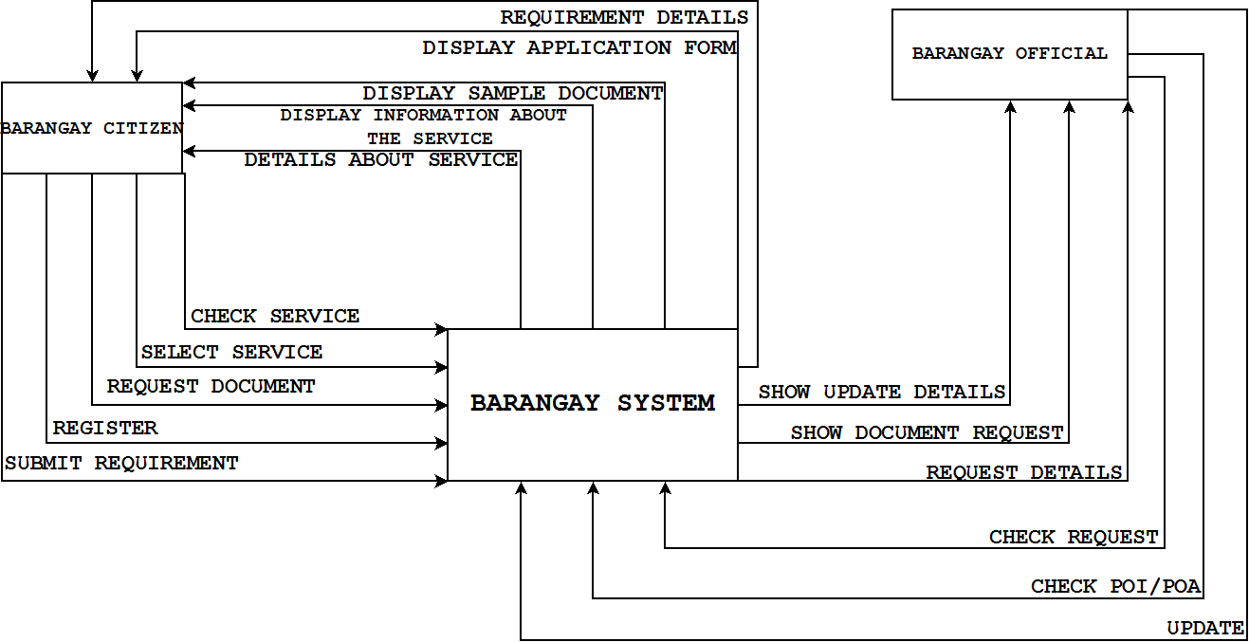 1. Context Level Data Flow**

**2. Level 0 Data Flow Diagram**

**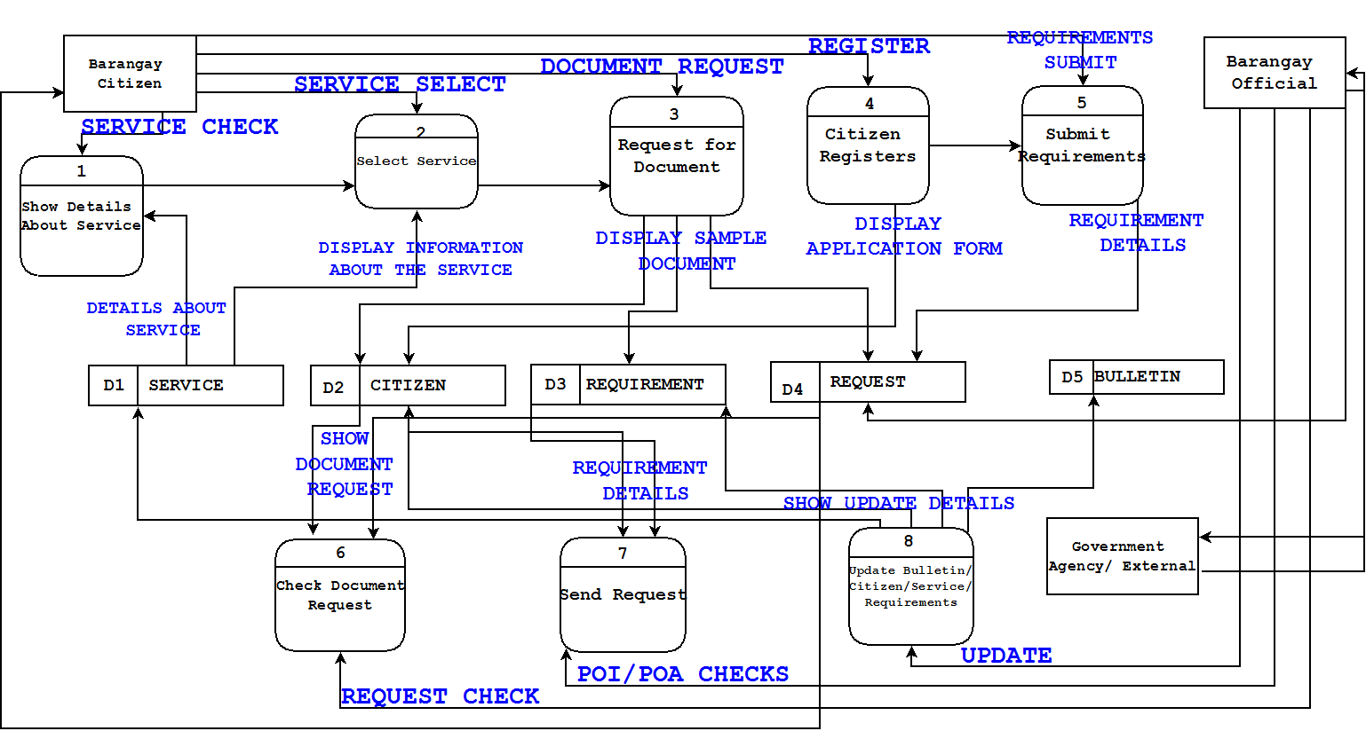**

**B. UML Diagram**

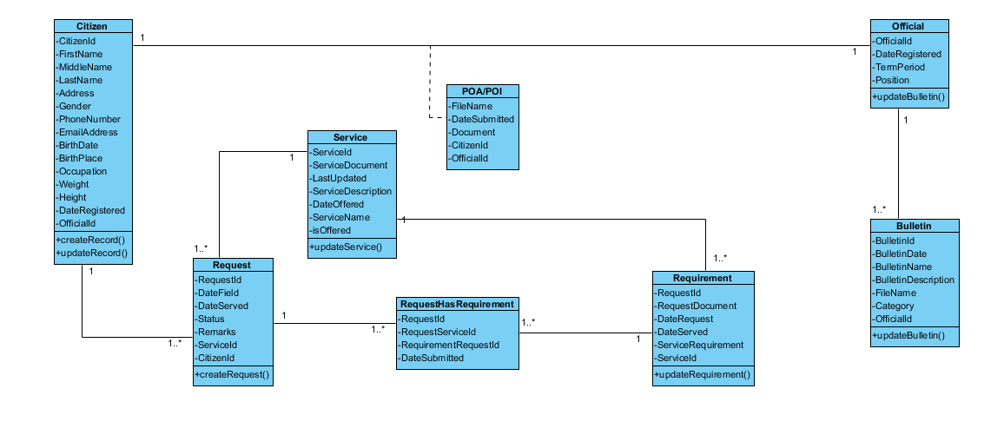**1. Class Diagram**

**2. Use Case Diagram**

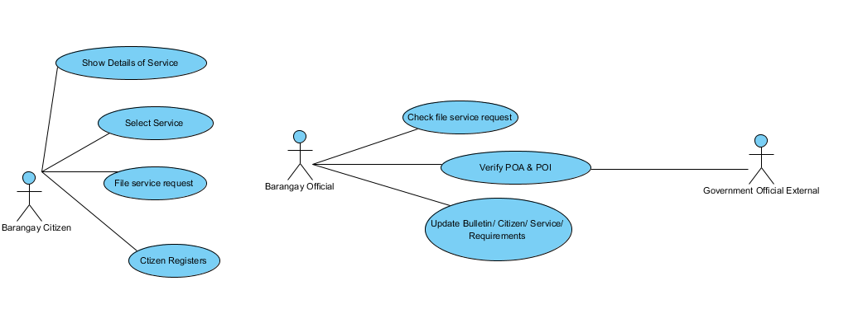

**3. Activity Diagram**

**a. Select Service**

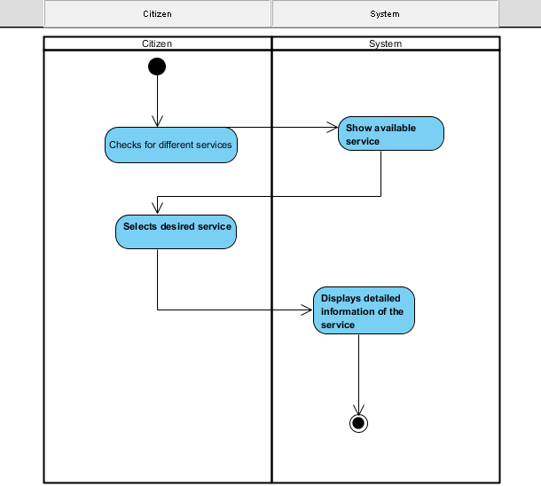

**b. File Service Request**

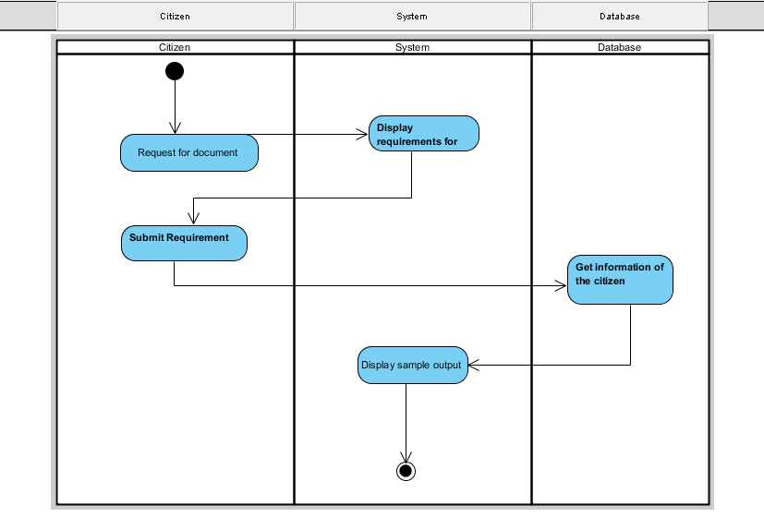

**c. Citizen Register**



**d. Check File Service Request**

****

**e. Verify Proof of Identity / Address (POI / POA)**

**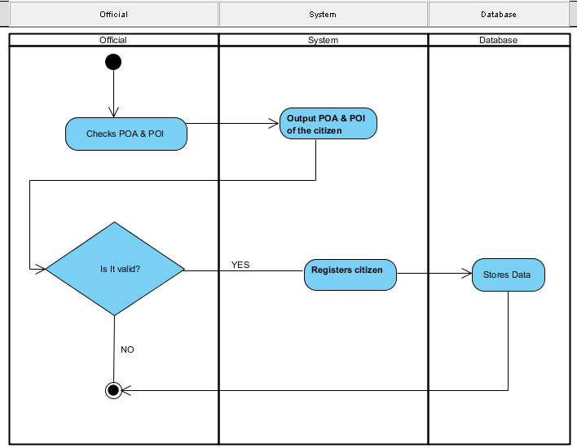**

**4. Sequence Diagram**

**a. Select Service**

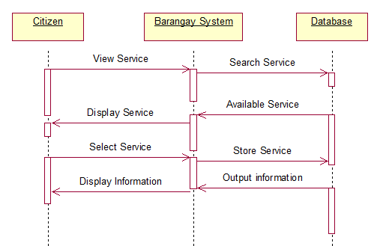

**b. File Service Request**

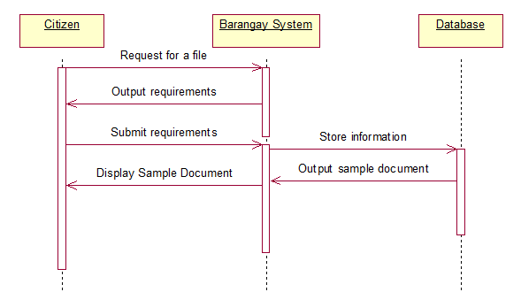

**c. Citizen Registers**

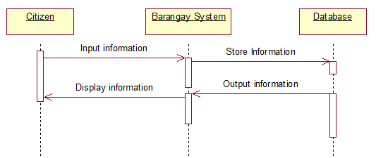

**d. Check File Service Request**

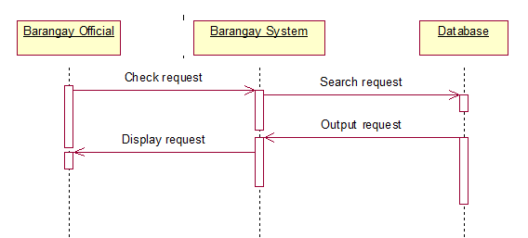

**e. Verify Proof of Identity / Address (POI / POA)**

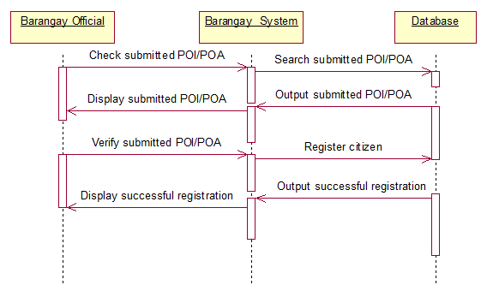

**f. Update Bulletin**

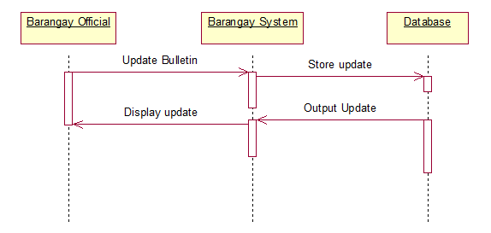

**5. Collaboration Diagram**

**a. Select Service**

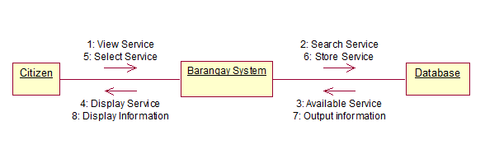

**b. File Service Request**

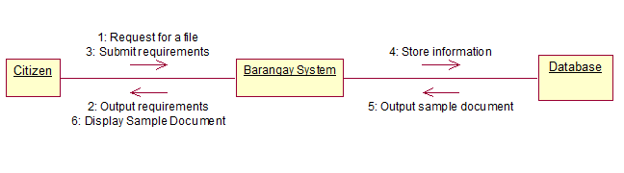

**c. Citizen Register**

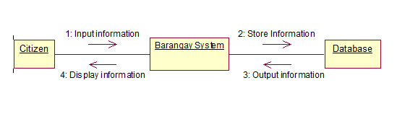

**d. Check File Service Request**

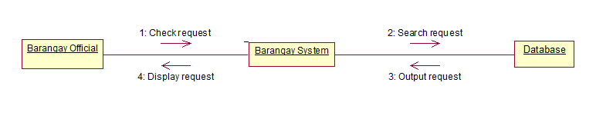

**e. Verify Proof of Identity / Address (POI / POA)**

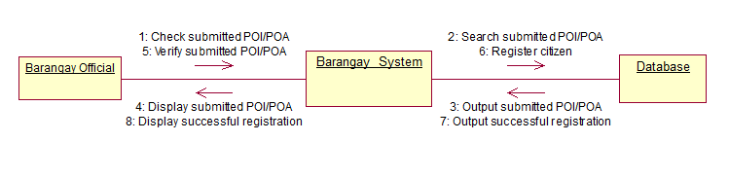

**f. Update Bulletin**

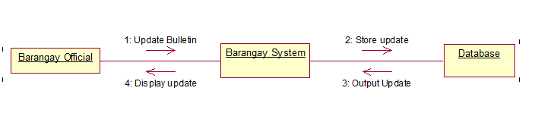

**6. Component Diagram**

**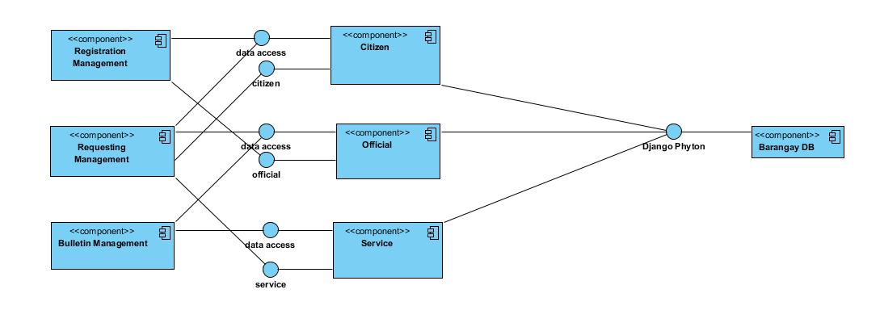**

**7. Composite Diagram**

**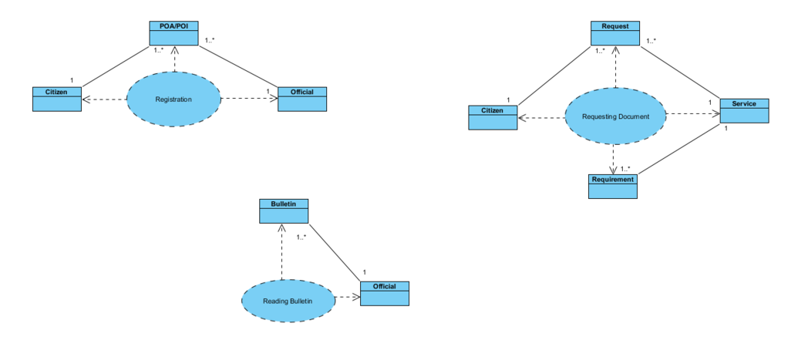**

**8. Deployment Diagram**

**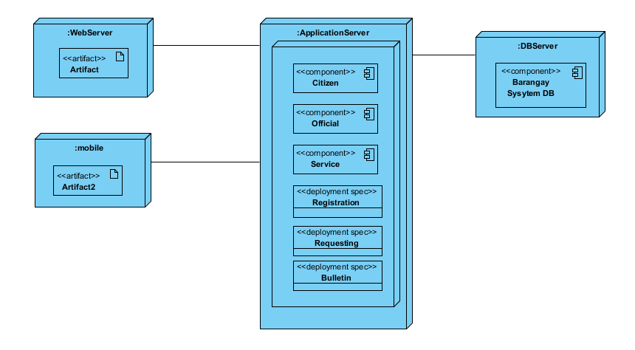**

**9. Interaction Diagram**

**a. Citizen Registers**

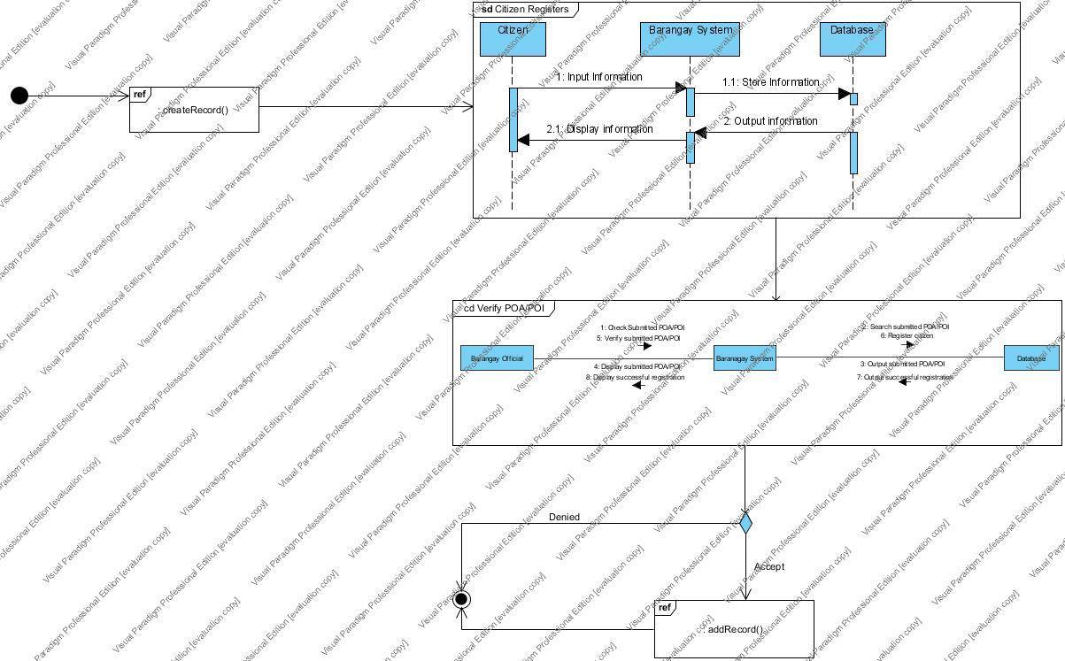

**b. Request Document**

**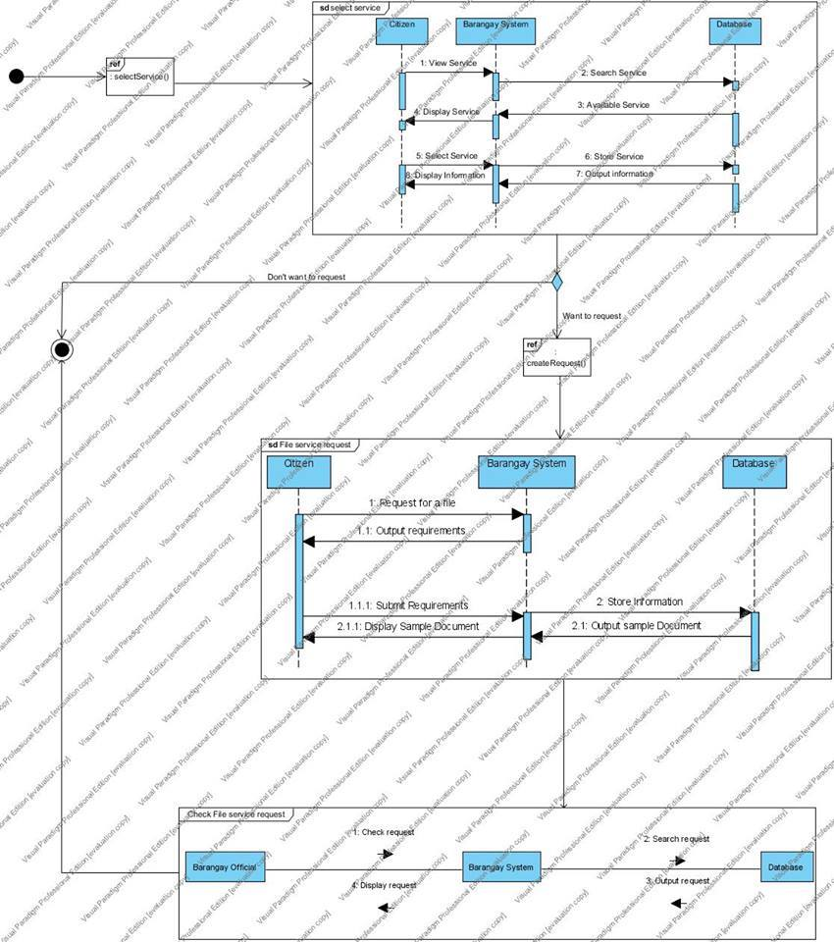**

**c. Update Bulletin**

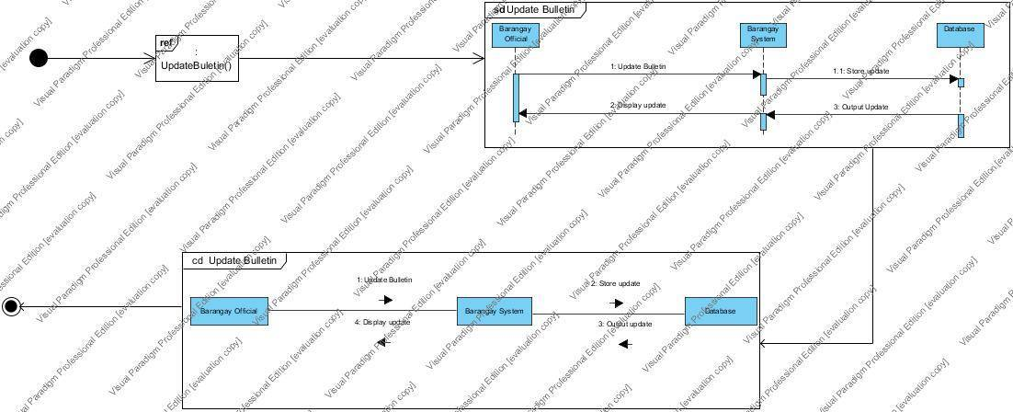

**10. Package Diagram**

**a. Citizen Registers**

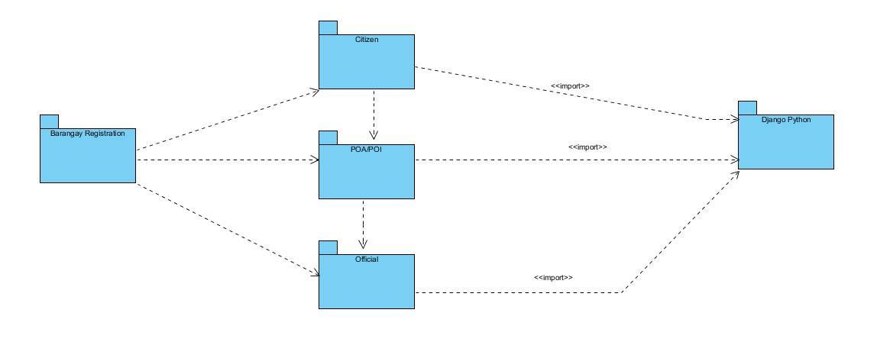

**b. Request Document**

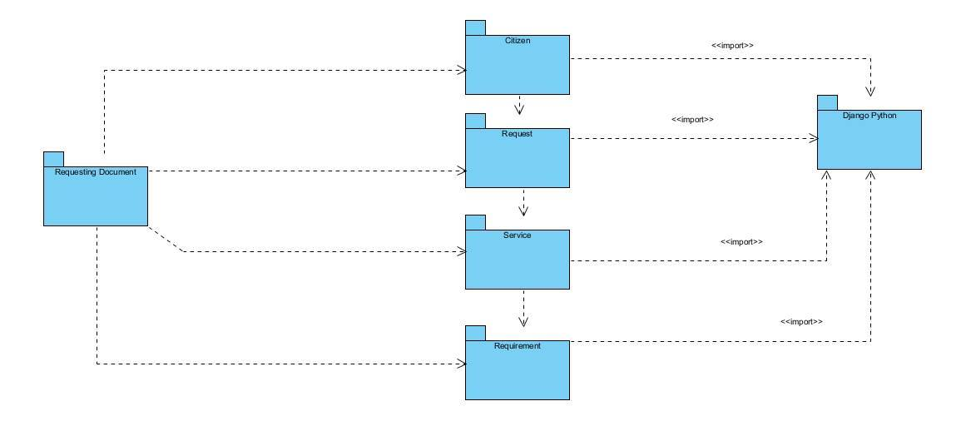

**c. Update Bulletin**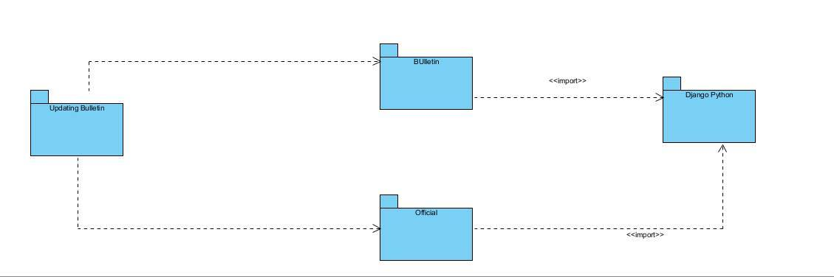

**11. Object Diagram**

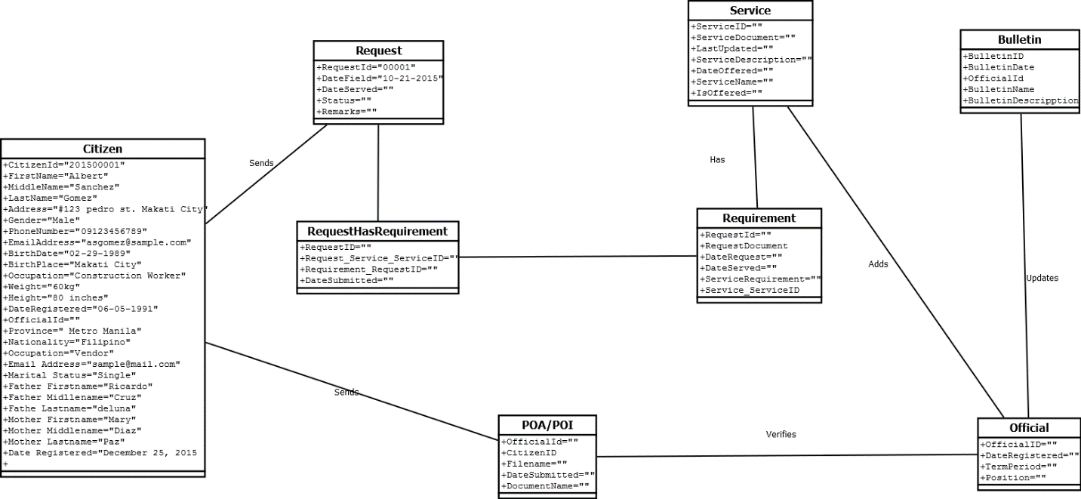

**12. State Machine Diagram**

**a. Citizen Register**

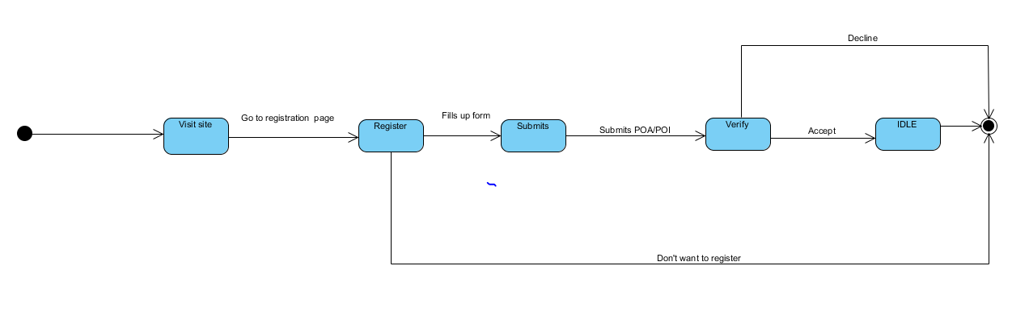

**b. Request Document**

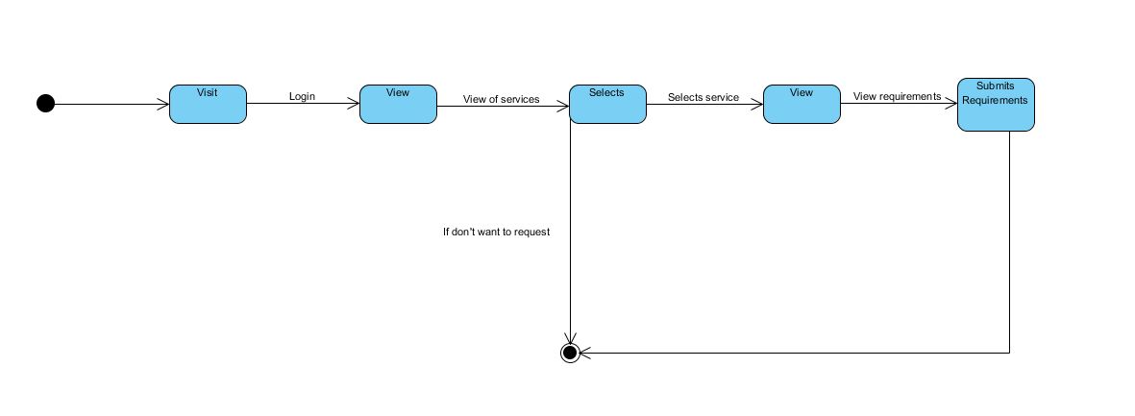

**13. Timing Diagram**

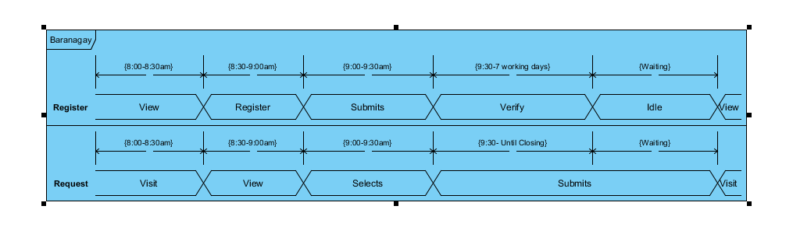

**C. Entity Relationship Diagram**

**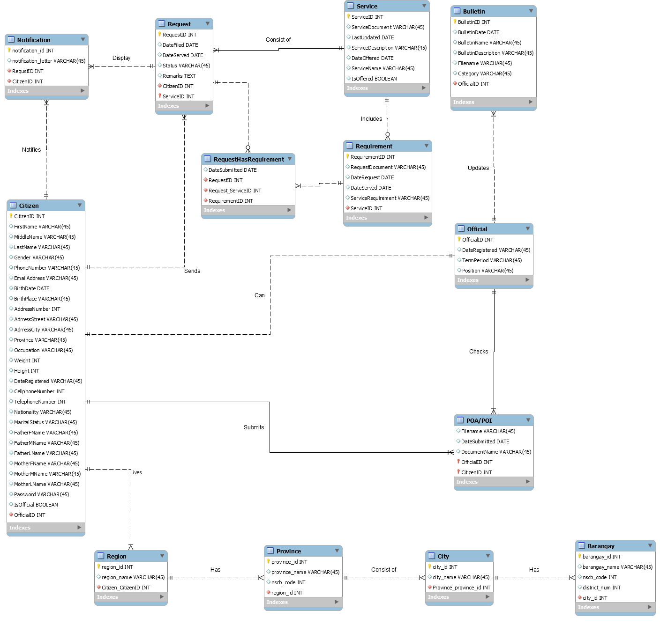**

**E. Data Dictionary**

**a. Barangay**

|  |  |  |
| --- | --- | --- |
| Attributes | Type | Required |
| barangay\_id | int | Yes |
| barangay\_name | varchar(45) | No |
| nscb\_code | int | No |
| district\_number | int | No |
| city\_id | int | No |

**b. Bulletin**

|  |  |  |
| --- | --- | --- |
| bulletin\_id | int | Yes |
| bulletin\_name | varchar(45) | No |
| bulletin\_description | text | No |
| bulletin\_date | date | No |
| file\_document | varchar(255) | No |

**c. Citizen**

|  |  |  |
| --- | --- | --- |
| citizen\_id | int | Yes |
| first\_name | varchar(45) | No |
| middle\_name | Varchar(45) | No |
| last\_name | Varchar(45) | No |
| gender | varchar(45) | No |
| citizen\_id | int | No |
| first\_name | varchar(45) | No |
| middle\_name | varchar(45) | No |
| last\_name | varchar(45) | No |
| gender | varchar(6) | No |
| birth\_date | date | No |
| birth\_place | varchar(45) | No |
| weight | decimal(6,2) | No |
| height | int(3) | No |
| civil\_status | varchar(45) | No |
| occupation | varchar(45) | No |
| cellphone\_number | int(11) | Yes |
| telephone\_number | int(7) | Yes |
| region | varchar(45) | No |
| province | varchar(45) | No |
| city | varchar(45) | No |
| district | varchar(45) | No |
| barangay | varchar(45) | No |
| zip\_code | int | No |
| street | varchar(45) | No |
| house\_number | varchar(45) | No |
| nationality | varchar(45) | No |
| username | varchar(45) | No |
| password | varchar(45) | No |
| email\_address | varchar(45) | Yes |
| father\_first\_name | varchar(45) | No |
| father\_middle\_name | varchar(45) | No |
| father\_last\_name | varchar(45) | No |
| mother\_first\_name | varchar(45) | No |
| mother\_middle\_name | varchar(45) | No |
| mother\_last\_name | varchar(45) | No |
| proof\_of\_identity | varchar(255) | No |
| proof\_of\_address | varchar(255) | No |
| is\_citizen | varchar(3) | No |
| date\_registered | date | No |
| is\_official | varchar(3) | No |

## d. City

|  |  |  |
| --- | --- | --- |
| city\_id | int | No |
| city\_name | varchar(45) | No |
| nscb\_code | int | No |
| province\_id | int | No |

## e. Notification

|  |  |  |
| --- | --- | --- |
| notification\_id | int | No |
| request\_id | int | No |
| citizen\_id | int | No |
| notification\_letter | text | No |

## f. Official

|  |  |  |
| --- | --- | --- |
| official\_id | int | No |
| official\_name | varchar(45) | No |
| position | varchar(45) | No |
| term\_period\_from | date | No |
| term\_period\_to | date | No |

## 

## g. Person

|  |  |  |
| --- | --- | --- |
| person\_id | int | No |
| first\_name | varchar(255) | No |
| middle\_name | varchar(255) | No |
| last\_name | varchar(255) | No |
| gender | varchar(255) | No |

## h. Province

|  |  |  |
| --- | --- | --- |
| province\_id | int | No |
| province\_name | varchar(45) | No |
| nscb\_code | int | No |
| region\_id | int | No |
| province\_id | int | No |

## i. Region

|  |  |  |
| --- | --- | --- |
| region\_id | int | No |
| region\_name | varchar(45) | No |
| nscb\_code | int | No |

## j. Request

|  |  |  |
| --- | --- | --- |
| request\_id | int | No |
| service\_id | int | No |
| citizen\_id | int | No |
| date\_filed | date | No |
| date\_served | date | No |
| status | varchar(45) | No |

## k. Request\_has\_requirement

|  |  |  |
| --- | --- | --- |
| request\_has\_requirement\_id | int(11) | No |
| date\_submitted | date | No |
| requirement\_document | varchar(255) | No |

## l. Requirement

|  |  |  |
| --- | --- | --- |
| requirement\_id | int | No |
| service\_id | int | No |
| service\_requirement | varchar(45) | No |

## m. Service

|  |  |  |
| --- | --- | --- |
| service\_id | int | No |
| service\_name | varchar(45) | No |
| service\_description | Varchar(45) | No |
| date\_offered | date | No |
| is\_offered | varchar(3) | No |

## F. Screenshots

## 

Login Page

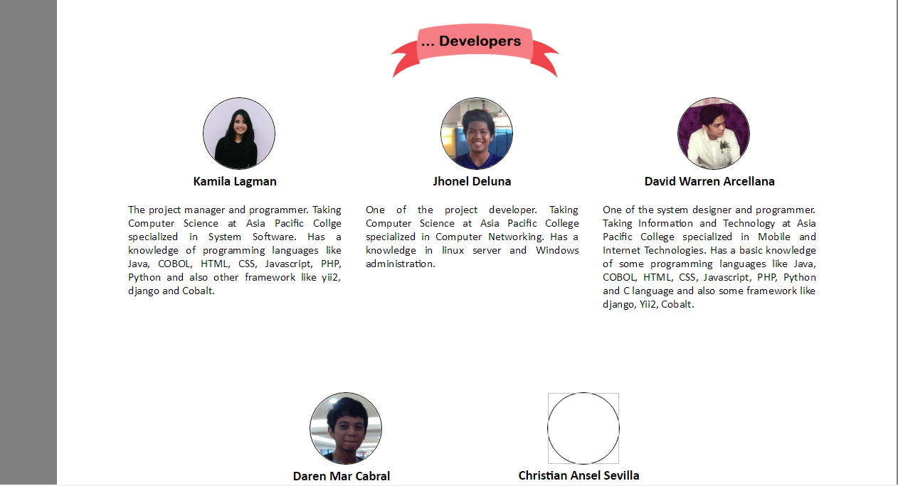

About Page

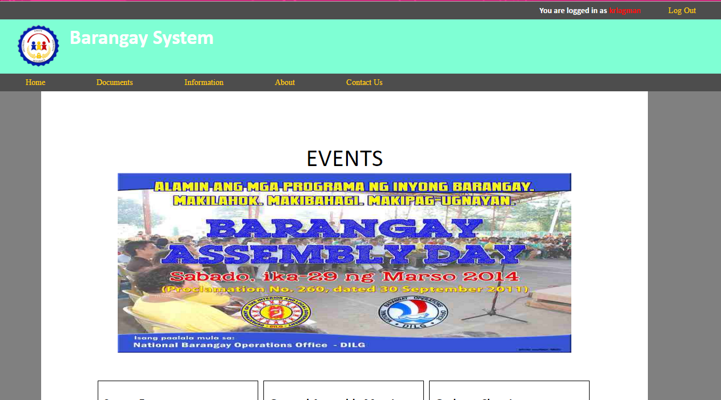

## Home Page

## Request Page

## G. Lesson Learned

## While we are developing the project, we used Cobalt framework for the database and functions of the system it is a PHP based framework. Recommended by our project adviser Mr. Allan Sta. Cruz. Because of the Cobalt we learned so much about PHP like filtering of the places based on the region, province, and city down to barangay.

## We make use of the SDLC method for organizing the work do that we know our progress and improvement because of the method of SDLC, we also learned how to manage time and focus on what we are improving or developing.

## Without the support of our project adviser, we will having a hard time to develop some of the main function and procedures of the system.

## 

## III. Appendices

**1. Relevant Source Code  
 a. Main.php**

<?php

$page\_title='Barangay System';

$stylesheet\_link='style';

$rstylesheet\_link='responsive';

require 'header.php';

require\_once 'path.php';

init\_cobalt();

if(xsrf\_guard())

{

init\_var($\_POST['btnSubmit']);

if($\_POST['btnSubmit'])

{

require 'password\_crypto.php';

$error\_message = '';

extract($\_POST);

//Deal with passwords longer than MAX\_PASSWORD\_LENGTH (possible DoS vulnerability)

if(strlen($password) > MAX\_PASSWORD\_LENGTH)

{

//Reset password to an arbitrarily small string, thwarting any DoS attempt

$password = 'x';

}

$data\_con = new data\_abstraction;

$mysqli = $data\_con->connect\_db()->mysqli;

$clean\_username = $mysqli->real\_escape\_string($username);

$clean\_password = cobalt\_password\_hash('RECREATE', $password, $username);

//FIXME: remember to update this ancient code to use prepared statement

$mysqli->real\_query("SELECT `username`, `skin\_id`, `first\_name`, `middle\_name`, `last\_name` FROM `user`, `person` WHERE `username`='$clean\_username' AND `password`='$clean\_password' AND `user`.`person\_id` = `person`.`person\_id`");

if($result = $mysqli->use\_result())

{

if($data = $result->fetch\_assoc())

{

$result->close();

extract($data);

$\_SESSION['logged'] = 'Logged';

$\_SESSION['user'] = $username;

$\_SESSION['first\_name'] = $first\_name;

$\_SESSION['middle\_name'] = $middle\_name;

$\_SESSION['last\_name'] = $last\_name;

$\_SESSION['ip\_address'] = get\_ip();

$data\_con = new data\_abstraction;

$data\_con->set\_fields('skin\_name, header, footer, master\_css, colors\_css, fonts\_css, override\_css, icon\_set');

$data\_con->set\_table('system\_skins');

$data\_con->set\_where("skin\_id=?");

$bind\_params = array('i', $skin\_id);

$data\_con->stmt\_prepare($bind\_params);

$data\_con->stmt\_fetch('single');

if($data\_con->num\_rows==1)

{

extract($data\_con->dump);

$\_SESSION['header'] = $header;

$\_SESSION['footer'] = $footer;

$\_SESSION['skin'] = $skin\_name;

$\_SESSION['master\_css'] = $master\_css;

$\_SESSION['colors\_css'] = $colors\_css;

$\_SESSION['fonts\_css'] = $fonts\_css;

$\_SESSION['override\_css'] = $override\_css;

$\_SESSION['icon\_set'] = $icon\_set;

if(trim($\_SESSION['icon\_set'] == ''))

{

$\_SESSION['icon\_set'] = 'cobalt';

}

}

$data\_con->close\_db();

log\_action('Logged in');

//check if user must rehash his password due to updated method or work factor/iterations

if(cobalt\_password\_must\_rehash($username))

{

$hashed\_password = cobalt\_password\_hash('NEW',$password, $username, $new\_salt, $new\_iteration, $new\_method);

$data\_con = new data\_abstraction;

$data\_con->set\_query\_type('UPDATE');

$data\_con->set\_table('user');

$data\_con->set\_update("`password`=?, `salt`=?, `iteration`=?, `method`=?");

$data\_con->set\_where("username=?");

$bind\_params = array('ssiss', $hashed\_password, $new\_salt, $new\_iteration, $new\_method, $username);

$data\_con->stmt\_prepare($bind\_params);

$data\_con->stmt\_execute();

}

redirect('home.php');

}

else $error\_message = "Check username and password.";

}

else die($mysqli->error);

$data\_con->close\_db();

}

}

$html = new html;

?>

<!DOCTYPE html>

<html>

<head>

<script>

if (top.location != location)

{

top.location.href = document.location.href ;

}

</script>

<title> <?php echo GLOBAL\_PROJECT\_NAME;?> - Powered by Cobalt</title>

<link href="css/login.css" rel="stylesheet" type="text/css">

<meta http-equiv="content-type" content="text/html; charset=<?php echo MULTI\_BYTE\_ENCODING; ?>" />

</head>

<body leftmargin="0" topmargin="0" marginwidth="0" marginheight="0" onload="document.getElementById('username').focus();">

<?php

echo '<form method="POST" action="' . basename($\_SERVER['SCRIPT\_NAME']) . '">';

$form\_key = generate\_token();

$form\_identifier = $\_SERVER['SCRIPT\_NAME'];

$\_SESSION['cobalt\_form\_keys'][$form\_identifier] = $form\_key;

echo '<input type="hidden" name="form\_key" value="' . $form\_key .'">';

?>

<div class="left\_container">

<div class="title">

<?php echo GLOBAL\_PROJECT\_NAME;?>

</div>

<div class="flavor\_text">

<?php

$enable\_flavor\_text = TRUE;

require 'login\_flavor\_text.php';

?>

</div>

</div>

<div class="right\_container">

<fieldset class="right\_panel">

<table border="0" width="100%" cellspacing="1">

<tr>

<td align="center">

<img src="login\_badge.png">

</td>

</tr>

<tr>

<td align="center">

<?php $html->draw\_text\_field('','username',FALSE,'text',FALSE, 'id="username" size="37" autocomplete="off" placeholder="Username"'); ?>

</td>

</tr>

<tr>

<td align="center">

<?php $html->draw\_text\_field('','password',FALSE,'password',FALSE,'maxlength="' . MAX\_PASSWORD\_LENGTH . '" size="37" autocomplete="off" placeholder="Password"'); ?>

</td>

</tr>

<tr>

<td align="center">

<input type=submit value="LOG IN" name="btnSubmit">

<?php

init\_var($error\_message);

$\_SESSION['icon\_set'] = 'cobalt';

$html->display\_error($error\_message);

?>

</td>

</tr>

</table>

</fieldset>

</div>

</form>

</body>

</html>

<?php

require 'footer1.php';

?>

**b. Register.php**

<?php

require 'path.php';

init\_cobalt();

$page\_title='Barangay System';

$stylesheet\_link='style';

require 'header.php';

$data\_con = new data\_abstraction;

$data\_con->set\_fields('skin\_name, header, footer, master\_css, colors\_css, fonts\_css, override\_css, icon\_set');

$data\_con->set\_table('system\_skins');

$data\_con->set\_where("skin\_id=1");

$data\_con->exec\_fetch('single');

if($data\_con->num\_rows==1)

{

extract($data\_con->dump);

$\_SESSION['header'] = $header;

$\_SESSION['footer'] = $footer;

$\_SESSION['skin'] = $skin\_name;

$\_SESSION['master\_css'] = $master\_css;

$\_SESSION['colors\_css'] = $colors\_css;

$\_SESSION['fonts\_css'] = $fonts\_css;

$\_SESSION['override\_css'] = $override\_css;

$\_SESSION['icon\_set'] = $icon\_set;

if(trim($\_SESSION['icon\_set'] == ''))

{

$\_SESSION['icon\_set'] = 'cobalt';

}

}

$data\_con->close\_db();

require 'components/get\_listview\_referrer.php';

if(xsrf\_guard())

{

init\_var($\_POST['btn\_cancel']);

init\_var($\_POST['btn\_submit']);

require 'components/query\_string\_standard.php';

require 'subclasses/citizen.php';

$dbh\_citizen = new citizen;

$object\_name = 'dbh\_citizen';

require 'components/create\_form\_data\_with\_upload.php';

extract($arr\_form\_data);

if($\_POST['btn\_cancel'])

{

log\_action('Pressed cancel button');

redirect("listview\_citizen.php?$query\_string");

}

$file\_upload\_control\_name="cf\_validate\_proof\_of\_id";

$mf\_upload\_counter\_name="validate\_count";

require 'components/upload\_generic\_mf.php';

$file\_upload\_control\_name="cf\_validate\_proof\_of\_address";

$mf\_upload\_counter\_name="validate\_count";

require 'components/upload\_generic\_mf.php';

if($\_POST['btn\_submit'])

{

log\_action('Pressed submit button');

$dbh\_citizen->fields['is\_citizen']['required'] = FALSE;

$dbh\_citizen->fields['is\_official']['required'] = FALSE;

$dbh\_citizen->fields['telephone\_number']['required'] = FALSE;

$dbh\_citizen->fields['email\_address']['required'] = FALSE;

$dbh\_citizen->fields['cellphone\_number']['required'] = FALSE;

$message .= $dbh\_citizen->sanitize($arr\_form\_data)->lst\_error;

extract($arr\_form\_data);

if($dbh\_citizen->check\_uniqueness($arr\_form\_data)->is\_unique)

{

//Good, no duplicate in database

}

else

{

$message = "Record already exists with the same primary identifiers!";

}

if($message=="")

{

$dbh\_citizen->add($arr\_form\_data);

$citizen\_id = $dbh\_citizen->auto\_id;

require\_once 'subclasses/validate.php';

$dbh\_citizen = new validate;

for($a=0; $a<$validate\_count;$a++)

{

$param = array(

'proof\_of\_id'=>$cf\_validate\_proof\_of\_id[$a],

'proof\_of\_address'=>$cf\_validate\_proof\_of\_address[$a],

'citizen\_id'=>$citizen\_id,

'status'=>$cf\_validate\_status[$a]

);

$dbh\_citizen->add($param);

}

require\_once 'subclasses/person.php';

$dbh\_person = new person;

$dbh\_person->add($arr\_form\_data);

$person\_id = $dbh\_person->auto\_id;

$arr\_form\_data['person\_id'] = $person\_id;

require 'password\_crypto.php';

//Hash the password using default Cobalt password hashing technique

$hashed\_password = cobalt\_password\_hash('NEW',$password, $username, $new\_salt, $new\_iteration, $new\_method);

$arr\_form\_data['password'] = $hashed\_password;

$arr\_form\_data['salt'] = $new\_salt;

$arr\_form\_data['iteration'] = $new\_iteration;

$arr\_form\_data['method'] = $new\_method;

$arr\_form\_data['role\_id'] = 3;

$arr\_form\_data['skin\_id'] = 1;

require\_once 'subclasses/user.php';

$dbh\_user = new user;

$dbh\_user->add($arr\_form\_data);

//Permissions from role, if role was chosen

if($arr\_form\_data['role\_id']!='')

{

$db = new data\_abstraction();

$db->execute\_query("INSERT `user\_passport` SELECT '" . quote\_smart($username) . "', `link\_id` FROM user\_role\_links WHERE role\_id='" . quote\_smart($arr\_form\_data['role\_id']) . "'");

}

redirect("listview\_citizen.php?$query\_string");

}

}

if ($arr\_form\_data['region'] != "")

{

$chosen\_region = $arr\_form\_data['region'];

}

if ($arr\_form\_data['province'] != "")

{

$chosen\_province = $arr\_form\_data['province'];

}

if ($arr\_form\_data['city'] != "")

{

$chosen\_city = $arr\_form\_data['city'];

}

if ($arr\_form\_data['barangay'] != "")

{

$chosen\_barangay = $arr\_form\_data['barangay'];

}

}

?>

<main>

<div class="register\_layout">

<?php

require 'subclasses/citizen\_html.php';

$html = new citizen\_html;

$html->draw\_header('Add Citizen', $message, $message\_type,TRUE,TRUE);

$html->draw\_listview\_referrer\_info($filter\_field\_used, $filter\_used, $page\_from, $filter\_sort\_asc, $filter\_sort\_desc);

require 'components/set\_region\_province\_city.php';

$html->fields['date\_registered']['control\_type'] = 'hidden';

$html->fields['is\_official']['control\_type'] = 'hidden';

$html->draw\_controls('add');

$html->draw\_footer();

?>

</div>

</main>

<?php

require 'footer.php';

?>

**c. documents.php**

<?php

$page\_title='Barangay System';

$stylesheet\_link='style';

require 'path.php';

init\_cobalt();

require 'header1.php';

require\_once 'subclasses/service.php';

$dbh\_service = new service;

$dbh\_service->execute\_query

("SELECT s.service\_name, r.service\_requirement FROM service s JOIN requirement r ON s.service\_id = r.service\_id WHERE is\_offered='yes'");

$result = $dbh\_service->result;

$service\_requirements = array();

while($row = $result->fetch\_assoc())

{

$service\_requirements[] = $row;

}

$dbh\_service->execute\_query

("SELECT DISTINCT service\_name, service\_description FROM service WHERE is\_offered='yes'");

$result = $dbh\_service->result;

$services = array();

while($row = $result->fetch\_assoc())

{

$services[] = $row;

}

?>

<main>

<section class="body-layout">

<center><h1>List of Documents</h1></center><br/><br/>

<center><table class="doctable">

<?php

echo "<tr class='doctable'>";

echo "<th class='doctable'>Service Name</th>";

echo "<th class='doctable'>Service Requirement</th>";

echo "<th class='doctable'>Serviced Description</th></tr>";

foreach ($services as $row) {

extract($row);

echo "<tr class='doctable'>";

echo "<td class='doctable'>$service\_name</td>";

echo "<td class='doctable'>";

foreach ($service\_requirements as $requirements) {

if ($requirements['service\_name'] == $row['service\_name']) {

echo"&#8226; " .$requirements['service\_requirement'] . "<br/>";

}

}

echo "<td class='doctable'>$service\_description</td></tr>";

}

?>

</table></center>

<br/><br/><br/>

<center><a class="btn" href="request.php">Request</a></center>

</section>

</main>

<?php

require 'footer.php';

?>

**d. Information.php**

<?php

$page\_title='Barangay System';

$stylesheet\_link='style';

require 'path.php';

init\_cobalt();

require 'header1.php';

require\_once 'subclasses/service.php';

$dbh\_service = new service;

$dbh\_service->execute\_query("SELECT bulletin\_id,bulletin\_name,bulletin\_description,file\_document FROM bulletin WHERE category in ('education','health') ");

$result = $dbh\_service->result;

?>

<main>

<div class="block-body">

<center><h1>Education</h1></center>

<!--<table border=3 width='1000px' >-->

<?php

while($row = $result->fetch\_assoc()) {

extract($row);

if(strlen($bulletin\_description) < 100)

{

//do nothing

}

else

{

$bulletin\_description = substr($bulletin\_description, 0, 99);

$bulletin\_description .= "&hellip;";

$bulletin\_description .= '<p><a href="showmore.php?b=' . $bulletin\_id . '">[Show more]</a></p>';

}

echo "<div class='home-layout home'>";

echo "<div class='descript'>";

echo "<h2>$bulletin\_name</h2>";

echo "<img class='homeimg' src='../../tmp/$file\_document' >";

echo "<p class='proj-descript'>$bulletin\_description<br></p>";

echo "</div>";

echo "</div>";

}

?>

<!--<?php

while($row = $result->fetch\_assoc()) {

extract($row);

/\*echo "<br>";

echo "<tr><td><h2>$bulletin\_name</h2><td>";

echo "<td>$bulletin\_description<br></td>";

echo "<td><img width='500px' height='200px'src='wash.png'></td></tr>";\*/

echo "<div class='home-layout info'>";

echo "<div class='descript-info'>";

echo "<h2>$bulletin\_name</h2>";

echo "<p class='proj-descript'>$bulletin\_description<br></p>";

echo "</div>";

echo "</div>";

}

?>-->

<!--</table>-->

</div>

</main>

<?php

require 'footer.php';

?>

**2. User’s Manual**

USER MANUAL:

* + Application

This provides general information on the physical and logical.

* + Dialog Flow

This section provides the screen messages and responses that the user needs to key-in.

* + User Security and Privacy

This section covers and explains the different user security requirements and policies. This will detail the different user security requirements and policies. This will detail the different levels of access that would be assigned to specific types of users.

* + User Operating Procedures

This section covers the different user administrative task related ton using the system (i.e., logon procedures).

**ADMIN MANUAL:**

**Login**

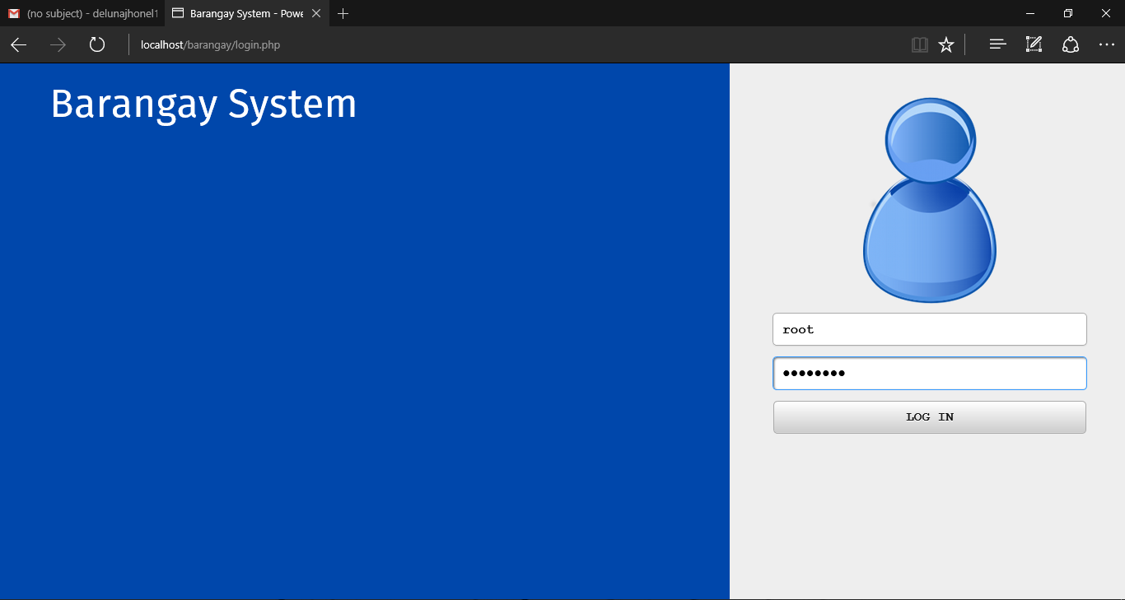

Login page:

1. Username: root (default)

2. Password: password (default)

**Site management**

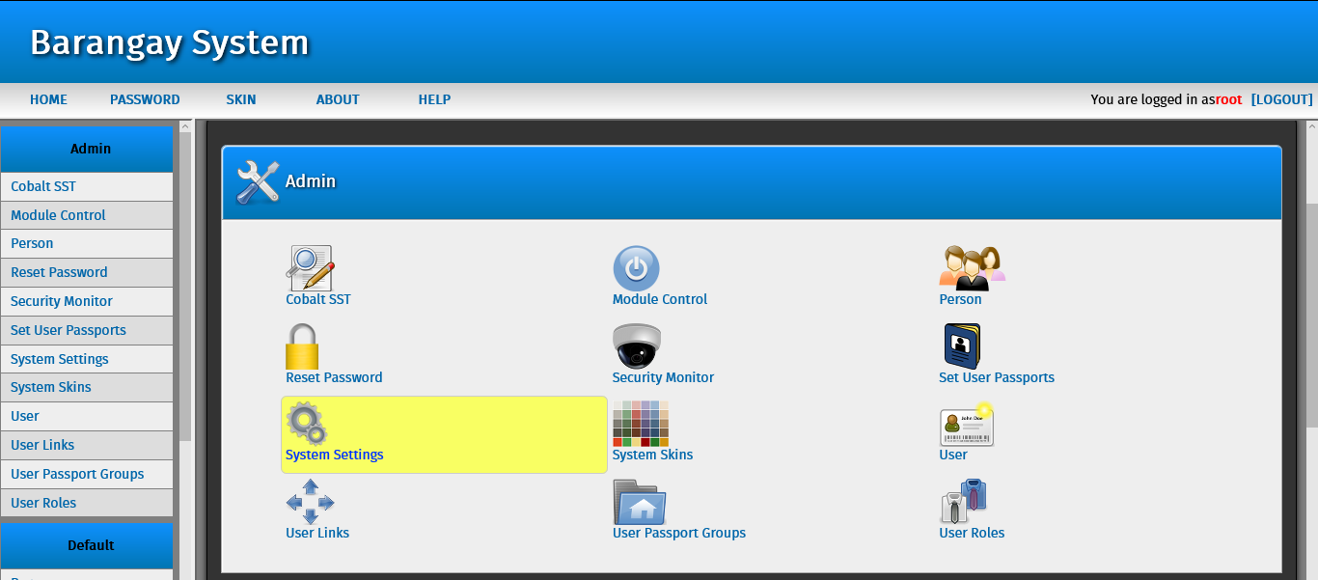

After login you will able to see this backend of the system (admin side).

In this page you able to manage this following important settings:

1. 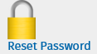 This icon is for changing the systems admin passwords.

2.  This is icon is to see the list of user or admin using this system.

3.  This icon is for changing the roles / permission of the admin.

**User management**

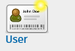 This icon is for creating another superuser or system admin.

After you click that icon you will need to see this page:

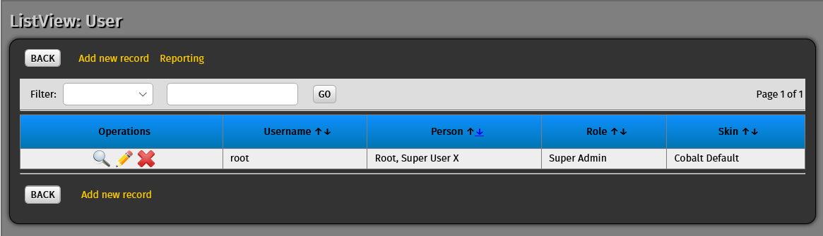

This is the list of all the admin as of now only root is the system admin and superuser but you can add another admin by clicking the “Add new record” button.

1. edit_button This icon is use to edit the setting to selected user.

2. view_button This icon is use to view all the information of the selected user.

3, delete This icon is use to delete user or admin in the site.

**Add site user**

To add another user click this  . After clciking that icon and you will see a form then click  and you will see this form:

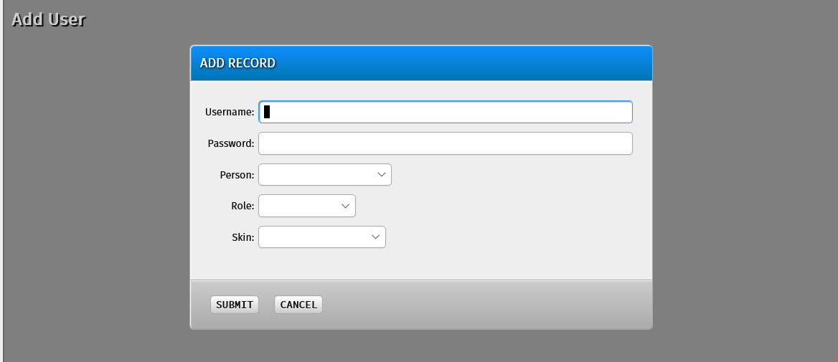

If you want make a new admin just fill up this for form and choose in the role if “System admin or Super user” the click submit.

**List of table in the database:**

1.  In this table you will able to add a official to the database.

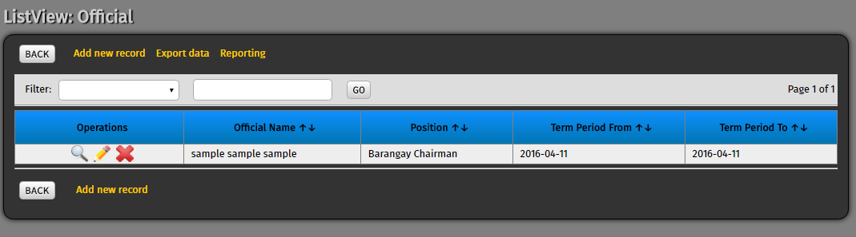

As you can see there is only one official, to another official just click  and you will transfer to the registration form.

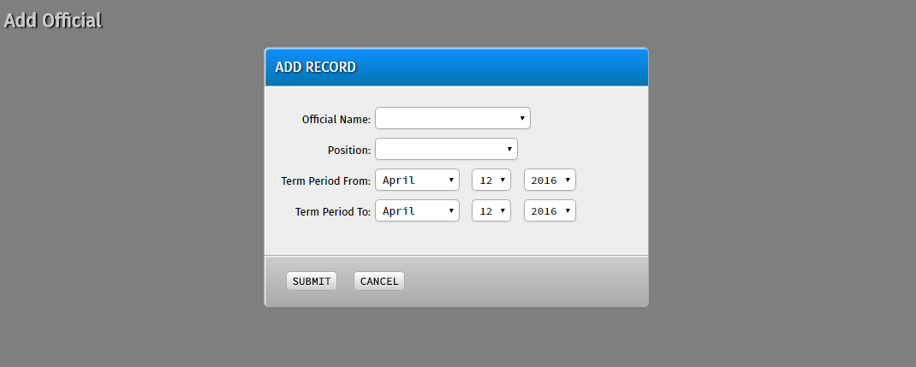

Make sure that you will fill up all the ask information because all the field is required to be filled, after filling up all the field then click .

2.  in this table you can add another services that your barangay will provide.

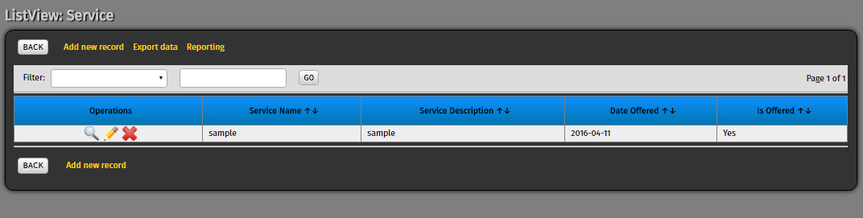

To another service just click  and you will transfer to the registration form.

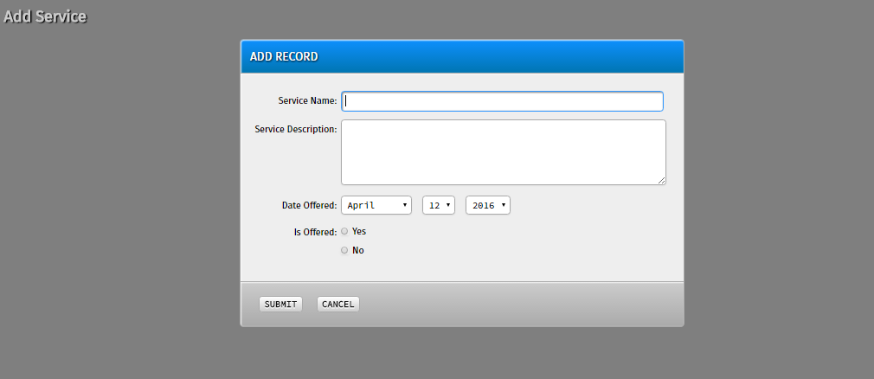

Make sure that you will fill up all the ask information because all the field is required to be filled, after filling up all the field then click .

3.  In this table you will able to see the list of all the user requested to your barangay and also in this table you need to put a status if the request is accepted or not accepted and waitlist for the system prompt the requestor.

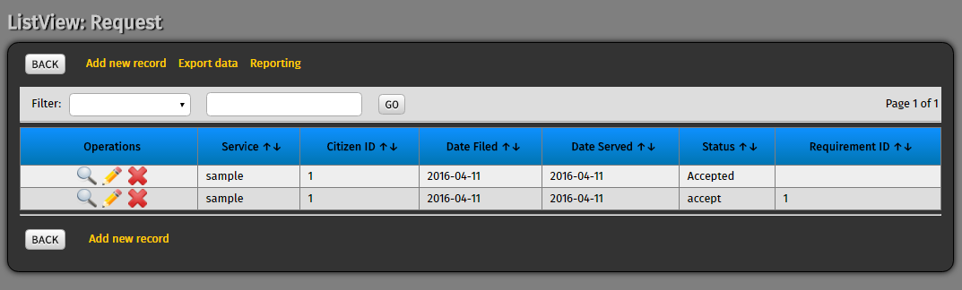

To add another request manually just click  and you will transfer to another form

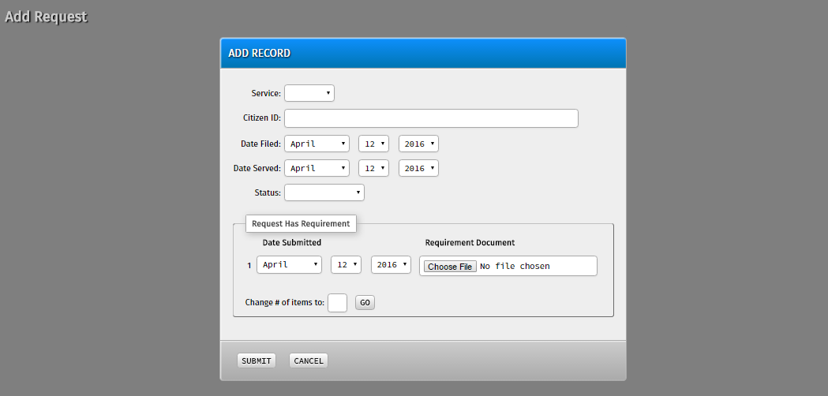

As you can see there is a portion of that form “Request Has Requirement” the citizen need to upload the required document and also you can request many just enter the number of your request  then click 

Make sure that you will fill up all the ask information because all the field is required to be filled, after filling up all the field then click .

4.  In this table will able to see the list of all the service and their respective requirements.

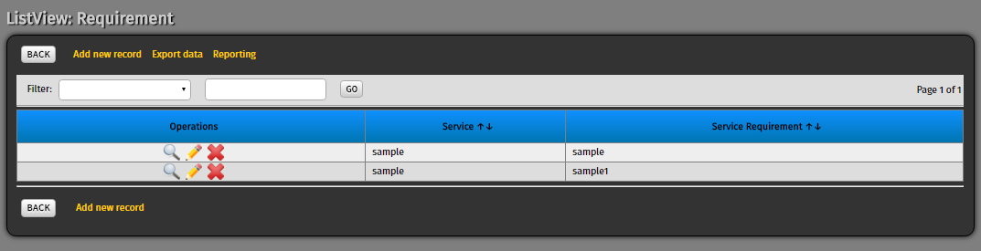

To add another requirement to a existing service manually just click  and you will transfer to another form

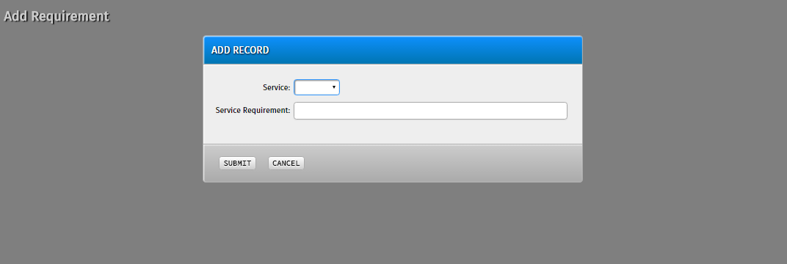

First you need to select a service to a requirement to it.

Make sure that you will fill up all the ask information because all the field is required to be filled, after filling up all the field then click .

5.  In this table you will able to see all the submitted requirements

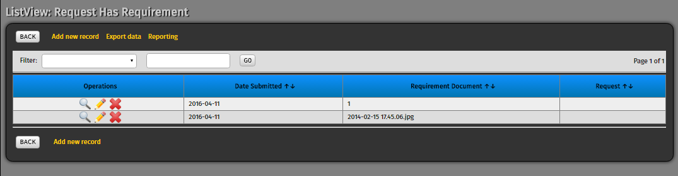

To upload another requirement to a existing service manually just click  and you will transfer to another form



Make sure that you will fill up all the ask information because all the field is required to be filled, after filling up all the field then click .

6.  In this table the admin need to validate the submitted POA/POI of the citizen

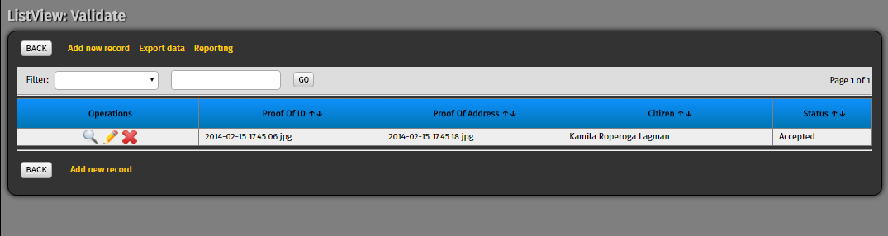

To add another record manually just click  and you will transfer to another form.

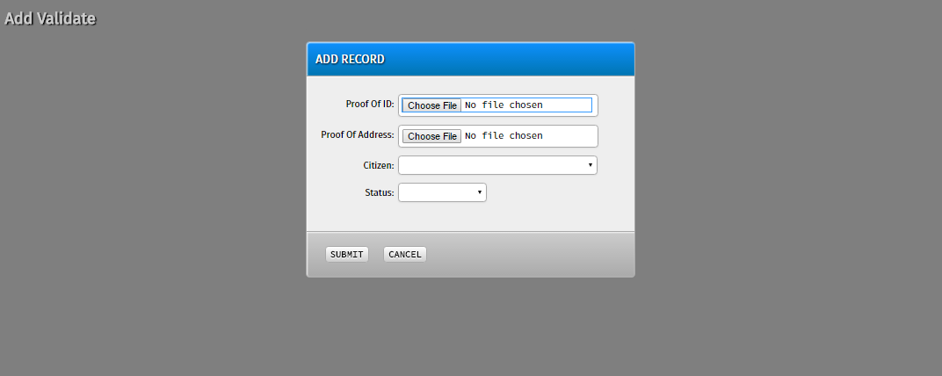

Make sure that you will fill up all the ask information because all the field is required to be filled, after filling up all the field then click .

7.  In this table you will able to see all the bulletin or announcment that the barangay will post in the main site.

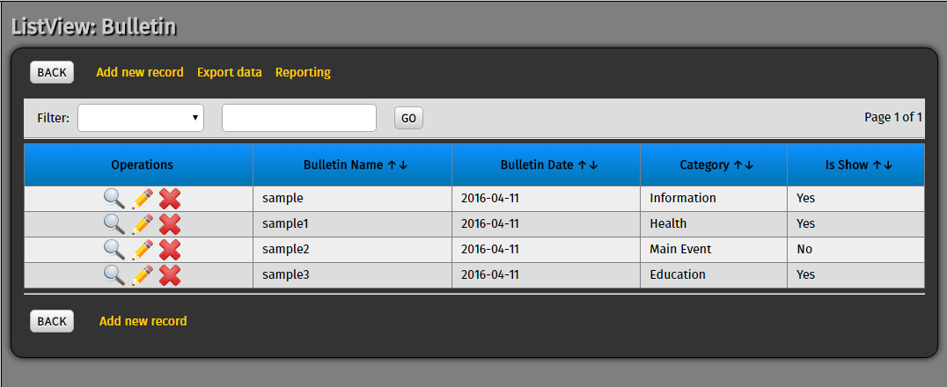

To add another announcement or event manually just click  and you will transfer to another form.

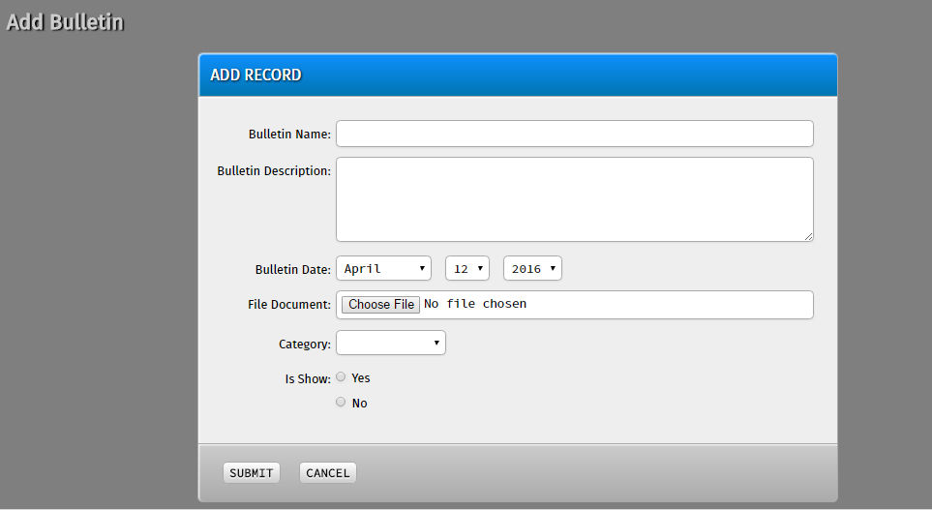

Make sure that you will fill up all the ask information because all the field is required to be filled, after filling up all the field then click .

8.  In this table the admin can send a letter to the citizen that request a service if their request is accepted or not.

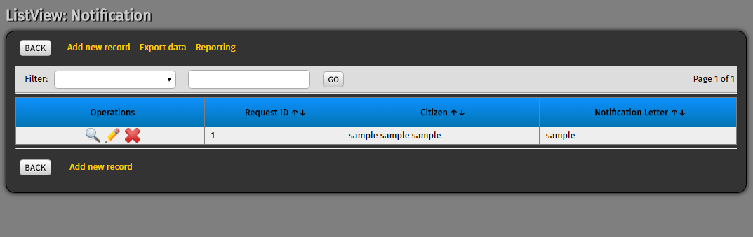

To add another notification manually just click  and you will transfer to another form.

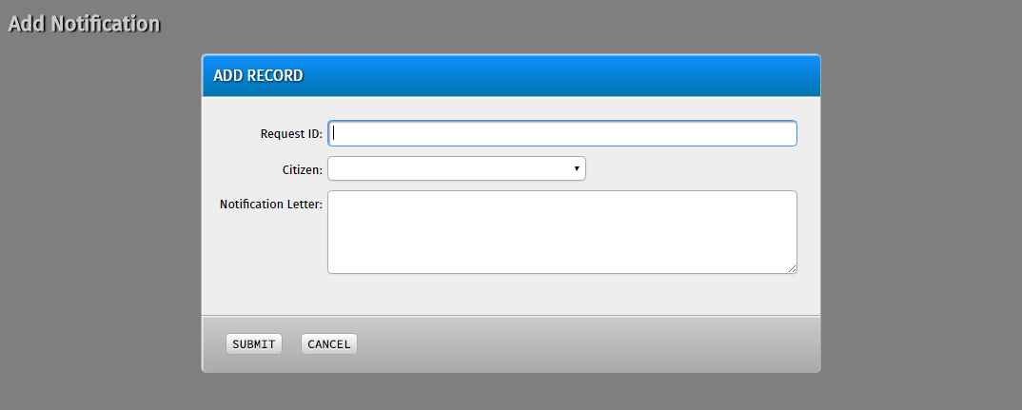

Make sure that you will fill up all the ask information because all the field is required to be filled, after filling up all the field then click .

9.  In this table you will able to see the list of all the regions in the Philippines.

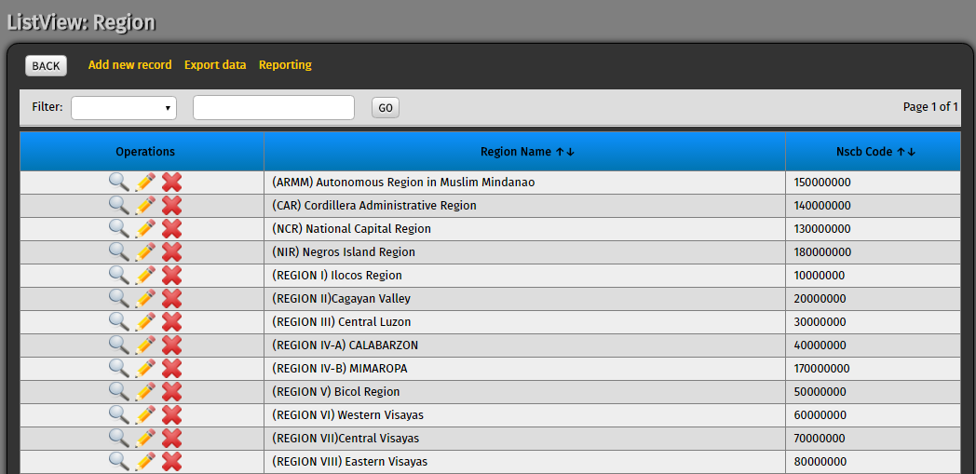To add another region manually just click  and you will transfer to another form.

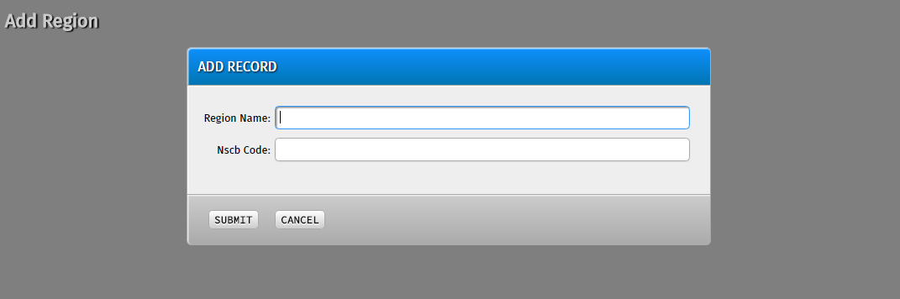

Make sure that you will fill up all the ask information because all the field is required to be filled, after  
filling up all the field then click .

10. In this table you will able to see the list of all the province in the philippines.

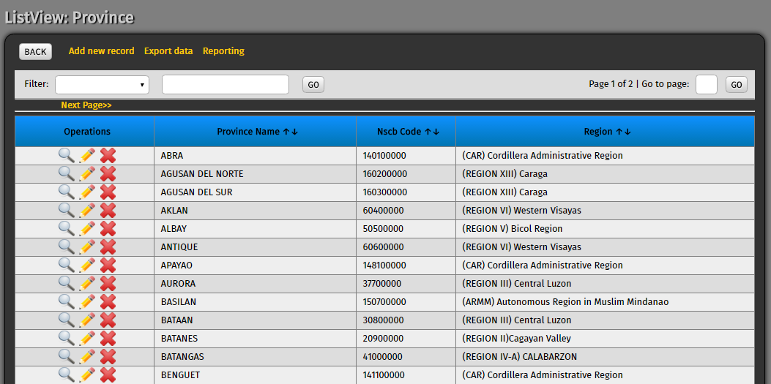

To add another province manually just click  and you will transfer to another form.

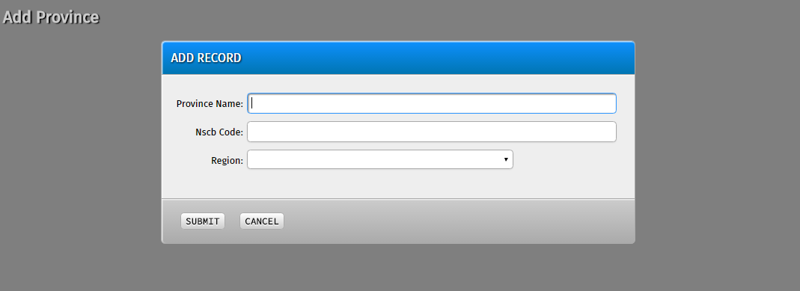

Make sure that you will fill up all the ask information because all the field is required to be filled, after filling up all the field then click .

11.  In this table you will able to see the list of all the city in the Philippines.

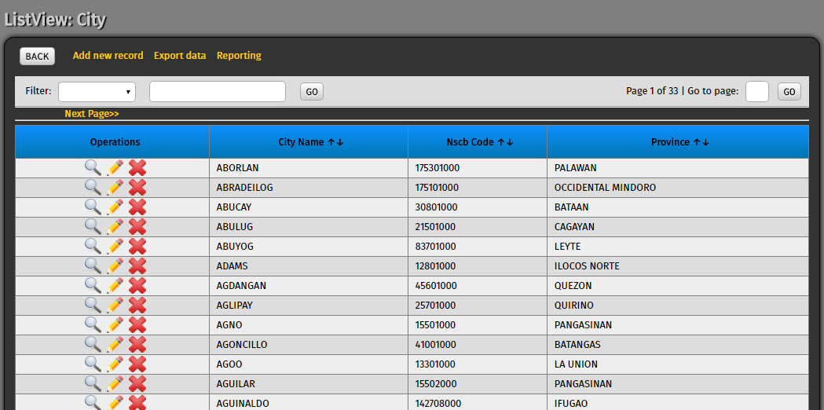To add another city manually just click  and you will transfer to another form.

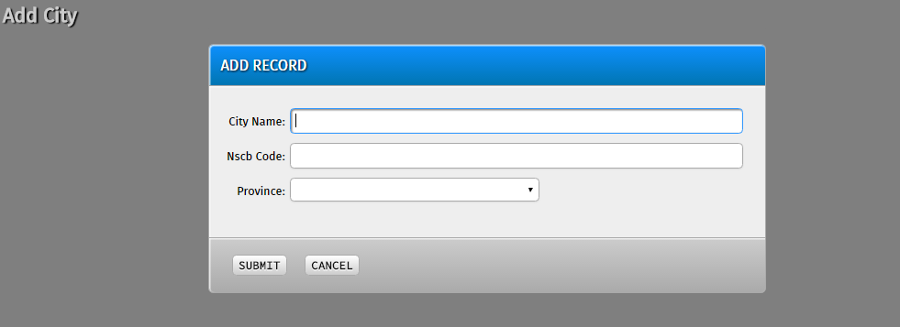

Make sure that you will fill up all the ask information because all the field is required to be filled, after filling up all the field then click .

12.  In this last table you will able to see the list of all the barangay in the Philippines.

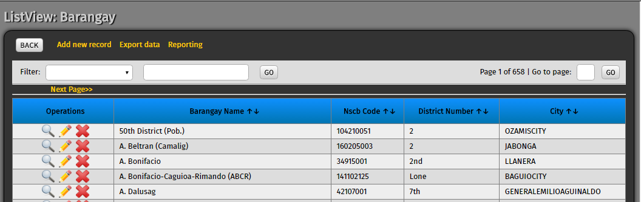To add another barangay manually just click  and you will transfer to another

Form

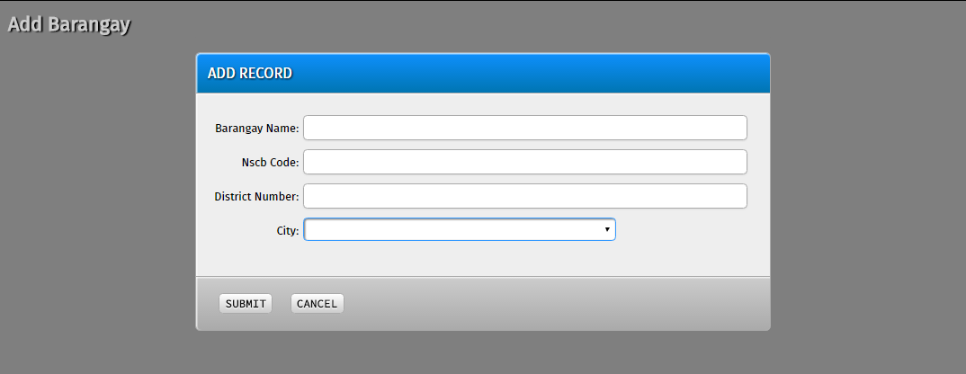

Make sure that you will fill up all the ask information because all the field is required to be filled, after filling up all the field then click .

**CITIZENS MANUAL:**

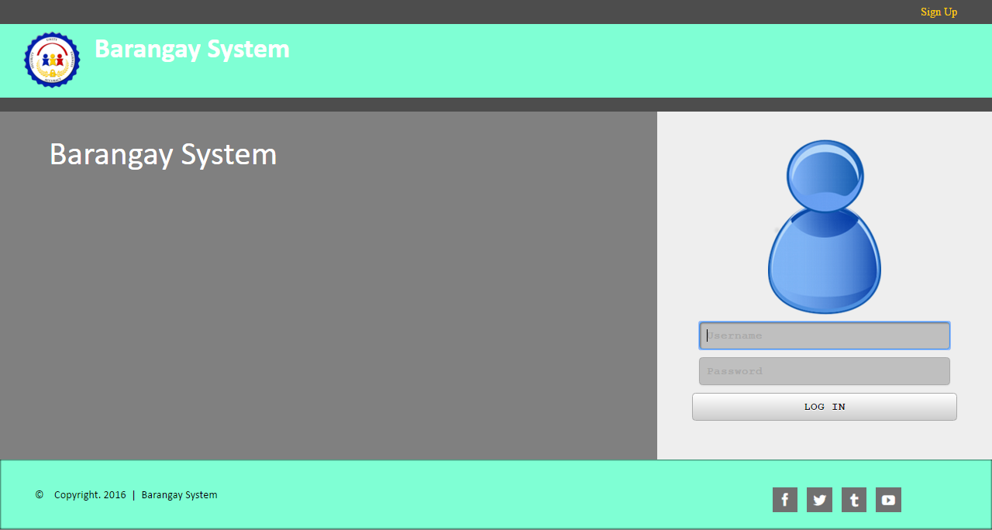

First, before the citizen can access the Barangay system they need to login. But before that the citizen need to register into the barangay.   
In the upper right corner of the 1st image the citizen must see a button “Sign up” this button will redirect to other page and will see this following forms:

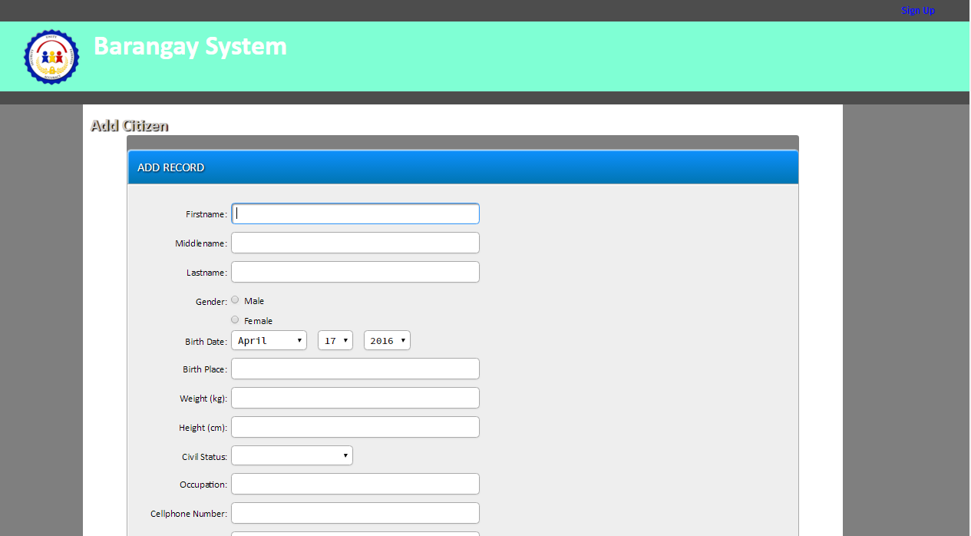

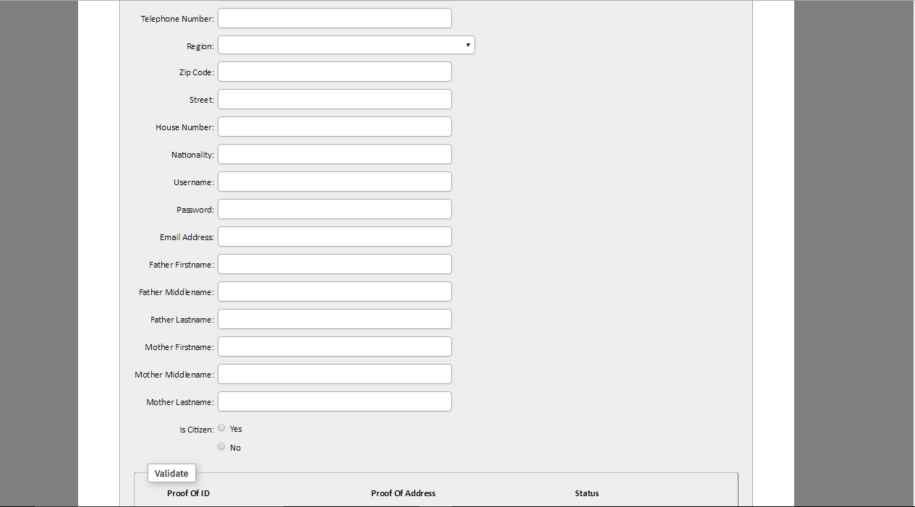

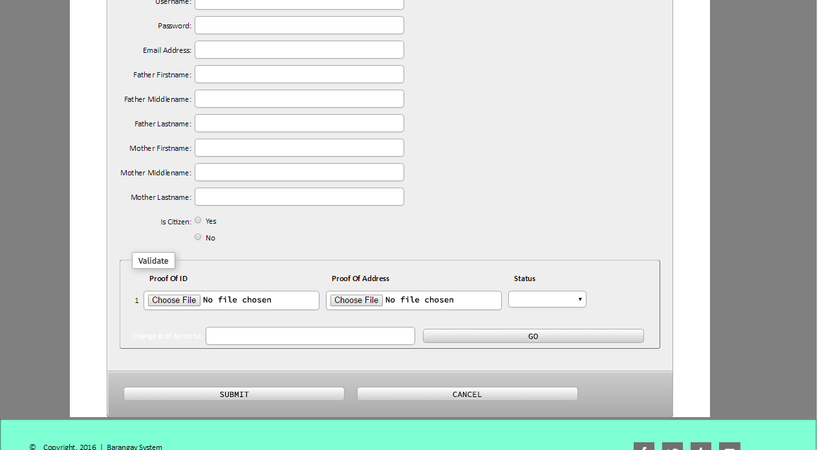

All field must be filled out, unless it will give the citizen an error.

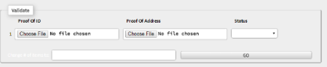

In this area in the registration form the citizen must upload a softcopy of their proof of ID example: Scanned Government Id’s (License, voters, sss, etc.). and also a proof of address, example: Scanned Utility bills (Meralco, Maynilad, Internet bills, etc.).

After the citizen fills out all the required information then click the button “Submit” to finish the registration to the system.



After registering the citizen can now login into the system using the username and password that they register erlier then click “LOG IN” then the citizen will transfer to the homepage of the barangay.



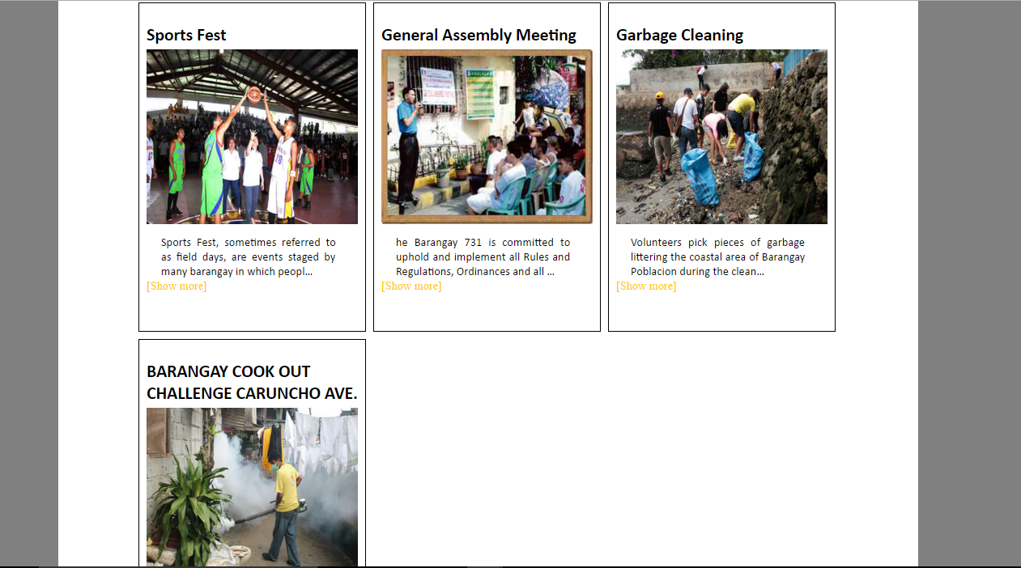

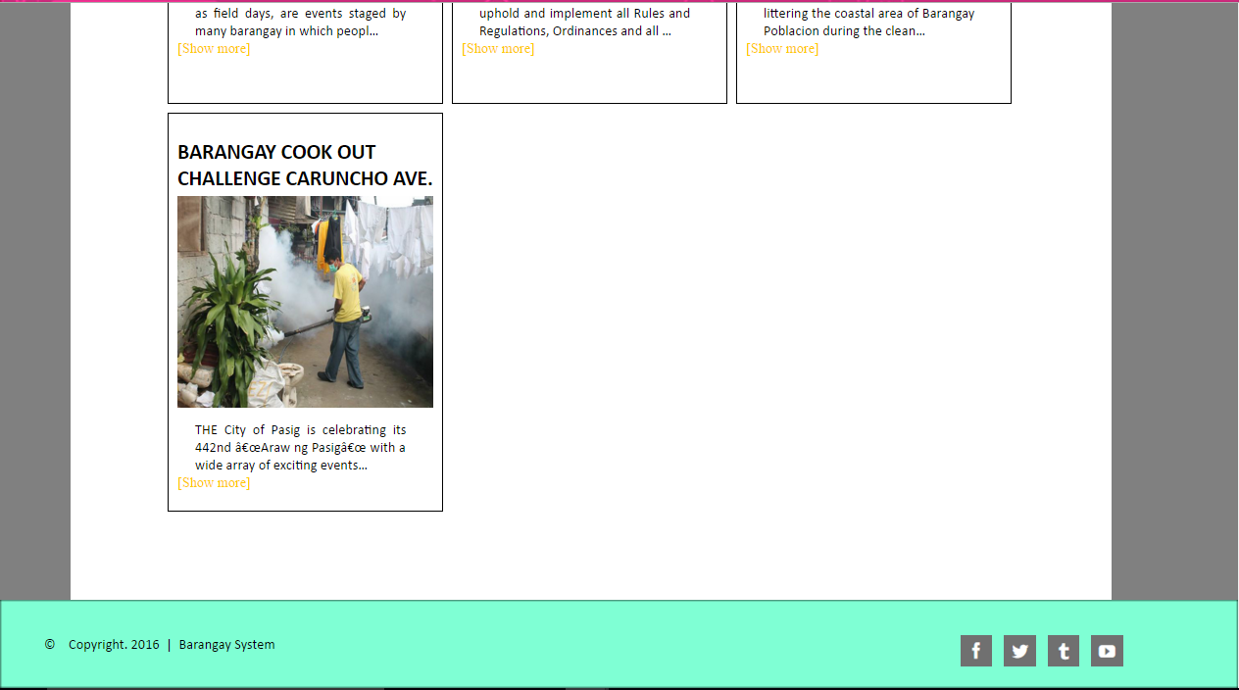

This is the Home Page of the barangay, All the events of the barangay can see by the citizen here. And in the top of the page the citizen will see a dashboard (HOME, DOCUMENTS, INFORMATION, CONTACT US AND ABOUT ). All the buttons has a following corresponding function:

**1. Documents**

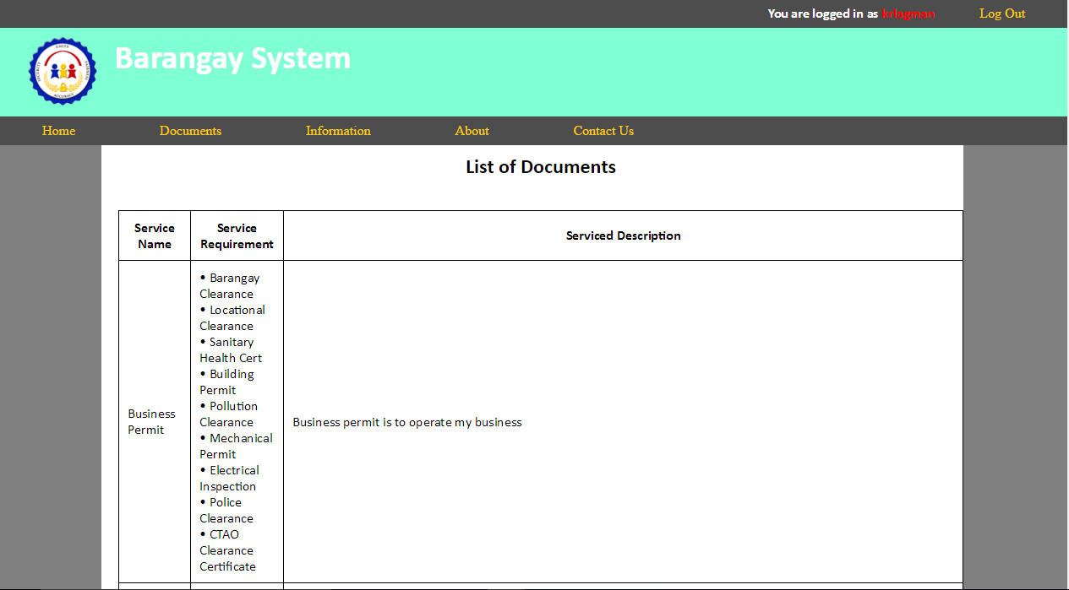

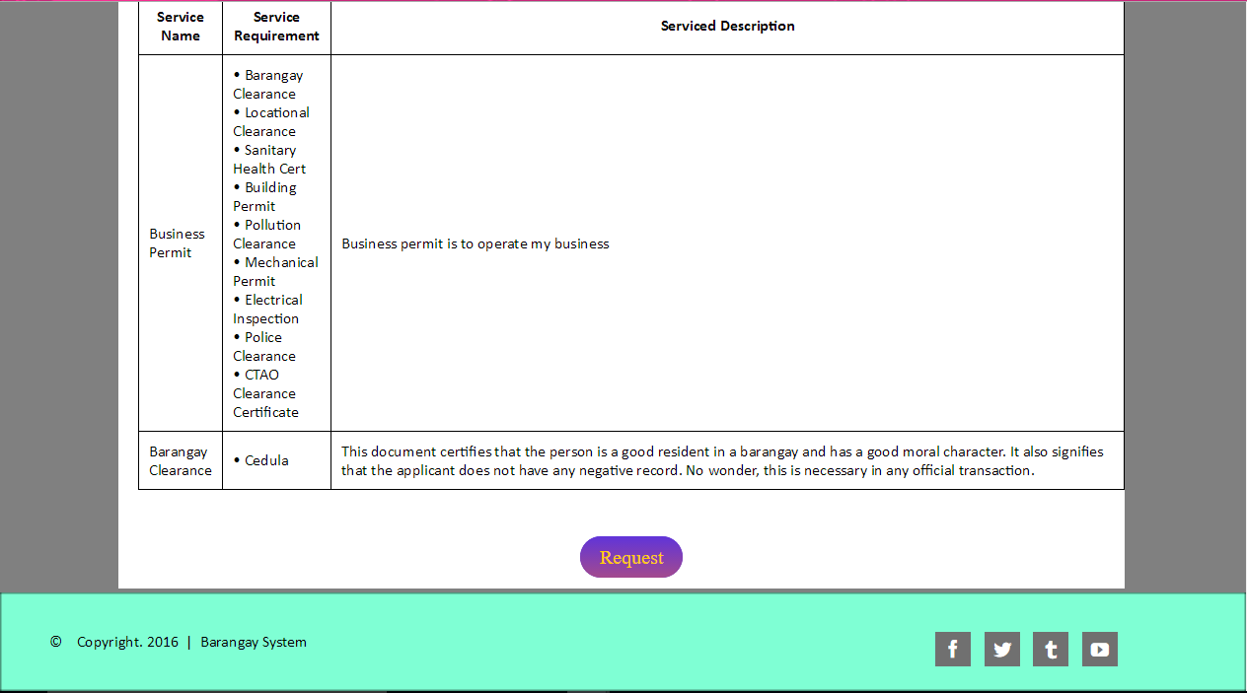

If the citizen wants to request a documents in the barangay just click “Documents” button and you will see this picture.

All the available documents offered by the barangay has listed here and if the citizen wants to request just click the button in the lower middle “Request”.

**2. Information**

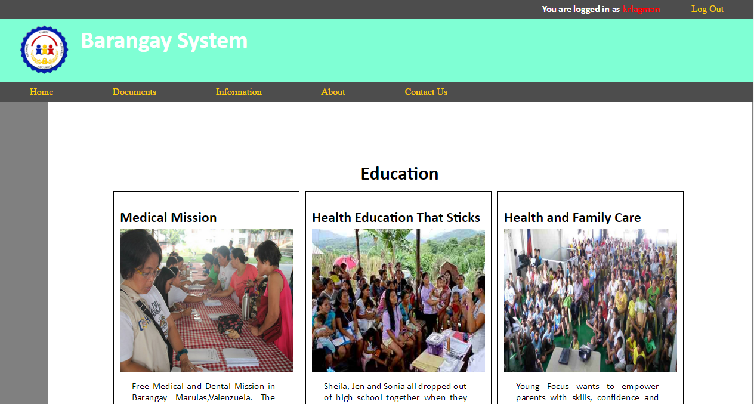

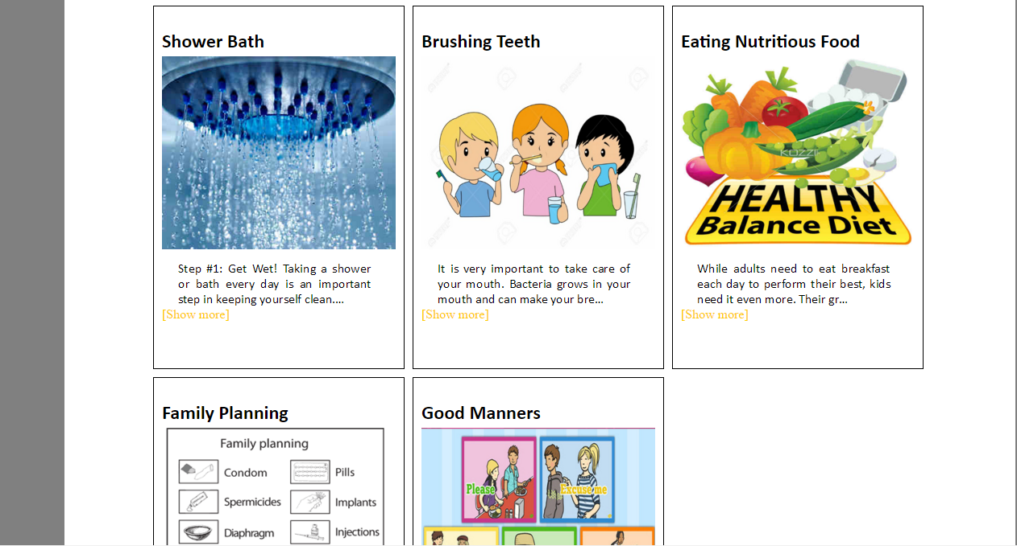

If the citizen wants to request a documents in the barangay just click “Information” button and you will see this picture.

All the information under a education section can seen by the citizen here.

Including:

1. Medical mission

2. Health Education that sticks

3. Health and family care

4. Shower bath

5. brushing Teeth

6. Eating nutritious food

7. Family Planning

8. Good manners

**3. About**

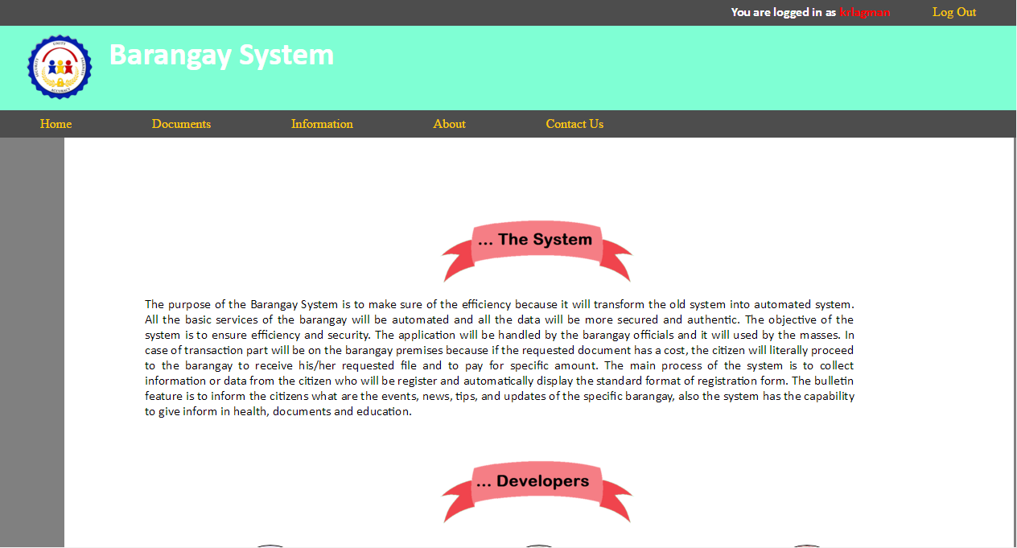



In this area the citizen can read about the system and the information about the developers.

**4. Contact Us**

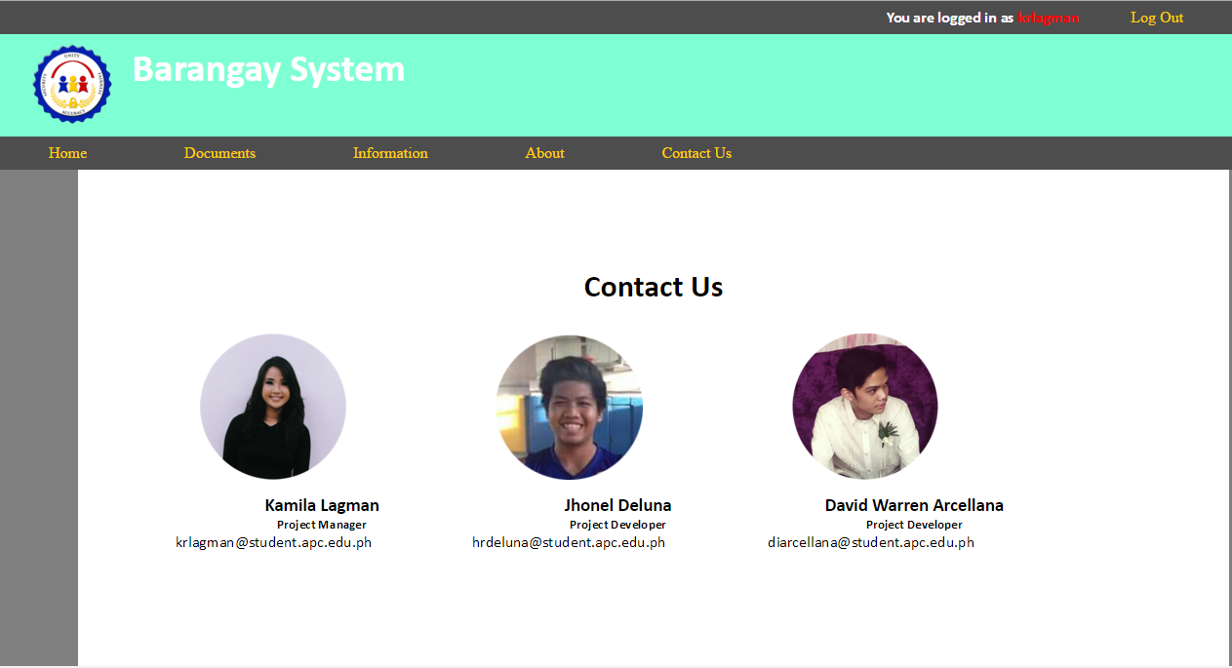

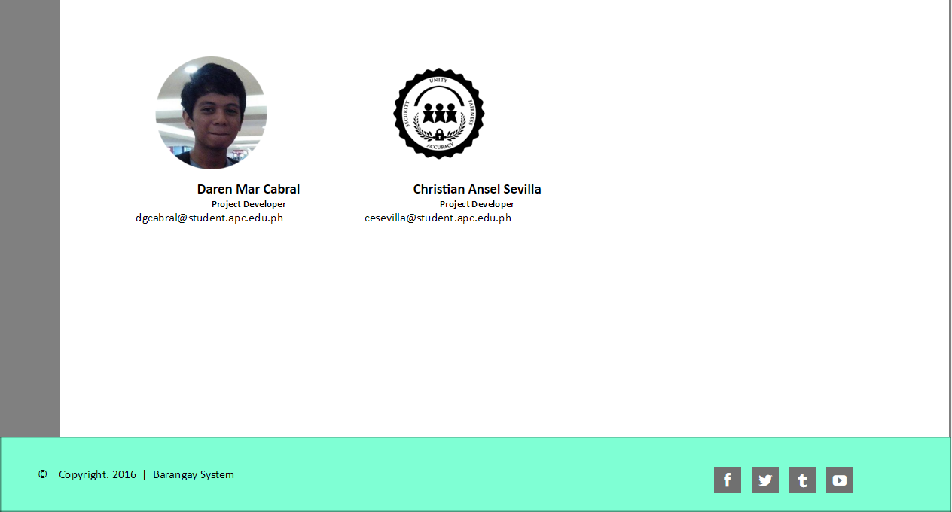

If the has any question about the system they can contact the developers by emailing them in their given email address.

**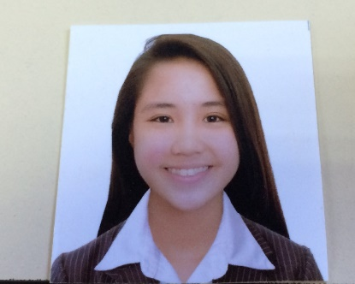** **3. Resume of the Members**

**LAGMAN, KAMILA R.**

**B.S. COMPUTER SCIENCE**

**SYSTEM SOFTWARE**

Unit # 923 central park condominium Pasay city

lagmankamila85@gmail.com

09954888256

**I. CAREER OBJECTIVE**

To work in a progressive organization which can expand all my knowledge and provided me exciting opportunities to utilize my skills and qualification to produce result fidelity. And To be part of reputed organization which provides a steady career growth along with job satisfaction, challenges and give value contribution in the success of organization.

**II. ACADEMIC INFORMATION**

2013-Present APC Asia Pacific College

#3 Humabon Place, Magallanes, Makati City

Bachelor of Science in Computer Science

2009-2013 BHS Bangkal High School

2003-2009 HPDPESM Heneral Pio Del Pilar Elementary School Main

|  |  |
| --- | --- |
| **Software Proficiency**   * My SQL * Microsoft Visual Studio * Green foot * XAMPP * Eclipse * Packet Tracer * Cobalt Framework * Yii2 Framework | **Programming Languages**   * JAVA * HTML * CSS * PHP * SQL * Visual Studio * Django Python |

**III. Activities**

* Finance Director of Microsoft Community, 2015- present
* Member of Student Ambassador and Models, 2014-present
* Assistant director in marketing and promotions of JPCS(Junior Philippine Computer Science), 2013-2014

 David Warren I. Arcellana

245 Teachers Bliss Kalayaan Village, Pasay City

09174840904

diarcellana@student.apc.edu.ph

**EDUCATION**

**Tertiary**

**2013-2017: Asia Pacific College, 3 Humabon Place, Magallanes, Makati City**

* Bachelor of Science in Information Technology Major in Mobile and Internet Technology
* Year of Graduation: 2017
* Relevant Coursework: Web & Mobile Application Developer, Networking, Database Designer

**Secondary**

2009-2013: Sta. Clara Parish School. Pasay City

**SKILLS AND INTERESTS**

* Typing, Drawing (using Illustrator), Editing (using Photoshop and other editing apps)
* Web Application Developing through HTML5, PHP, JavaScript, Python Programming using Django Framework
* Android Application Developing through Java Programming
* Play sports game, Watching movies, Traveling,

**REFERENCES**

* Ms. Arwena Manuel

Fourth Year High School Adviser and IT subjects Teacher

Sta.Clara Parish School

* Mr. Manuel Sanchez

College Professor, Project-Based Learning Professor and Adviser

Asia Pacific College

|  |  |  |
| --- | --- | --- |
| **Name:** | **JHONEL R. DELUNA** |  |
| **Complete Address:** | 532 Franciscan st, Sta. Ana Village |
| Brgy. Sun valley Paranaque City |
| **Contact**  **Number/s:** | Mobile no: 09069472394 |
| **Email Address:** | hrdeluna@student.apc.edu.ph  delunaJhonel123@gmailcom |

|  |  |  |
| --- | --- | --- |
| **Job Objective** | To look for a job position in the Information technology industry where I can acquire, perform and develop my best abilities, knowledge and skills to be well prepared as I work in a corporate world. | |
| **Education** | **Asia Pacific College**, Magallanes, Makati City  **BS in Tourism Management**  June 2012-present | |
| **Work-Related Courses** | * Data Communication * Data Networking * Operating System 1 & 2 * Advance Unix * Enterprise Unix * Introduction to System Development * Professional Ethics * System Analysis and Design * Applied Project 2 | * Project Management * Windows Server * Information Security * Web Programming * Web Services * Technology Entrepreneurship * Database management 1 & 2 * Data Structure |
| **Academic Projects** | **Barangay System ,**  June 2015 – April 2016  The purpose of the Barangay System is to make sure of the efficiency because it will transform the old system into automated system. All the basic services of the barangay will be automated and all the data will be more secured and authentic. The objective of the system is to ensure efficiency and security | |
| **Technical Skills** | Applications   * Linux Administration * Windows Administration * Data Networking * Knowledge in Computer hardware | |
| **Extra-Curricular Activities** | * Microsoft Society – 2015 - Present | |

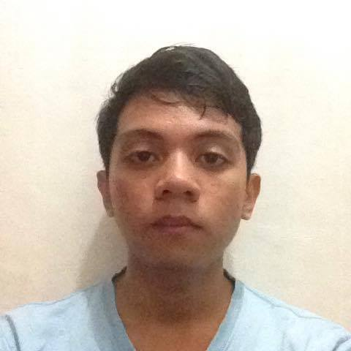

Daren Mar Galindo Cabral

98 B Alligator St. Brgy. Rizal, Makati City

09366541204

dgcabral@student.apc.edu.ph

**EDUCATION**

**Tertiary**

**2013-2017: Asia Pacific College, 3 Humabon Place, Magallanes, Makati City**

* Bachelor of Science in Information Technology Major in Mobile and Internet Technology
* Year of Graduation: 2017
* Relevant Coursework: Web & Mobile Application Developer, Networking, Database Designer

**Secondary**

**2009-2013: Benigno “Ninoy” S. Aquino High School, Aguho St., Commembo, Makati City**

**SKILLS AND INTERESTS**

* Typing, Editing (Using Paint, Photoshop and SAI Paint Tool).
* Web Application Developing through HTML5, PHP, JavaScript, and Python Programming using Django Framework.
* Android Application Developing through Java Programming.
* Play computer games, playing instruments like guitar, Reading Books, Manga, Light Novels, and Articles in the internet.

**REFERENCES**

* Mr. Manuel Sanchez

College Professor, Project-Based Learning Professor and Adviser

Asia Pacific College

**IV. Project Vision and Scope Document**

# **1. Business Requirements**

One of the business requirements of the Barangay System is to ensure the security of the database. Also, it is efficient to use because it can be accessible in any place as long as the user has an internet connection.

## a. Background

## One of the problems in the barangay is utilizing their old system that uses pen and paper. The problem, is about the data that are given to the barangay officials by the citizen which are not really secured and sometimes not authentic. For example the citizens of the barangay will be requesting for a barangay ID, the officials will ask their name and how long they have stayed in the barangay, knowing that the citizen can fake the given data. In system ensure that the data are legit and authentic. For will provide security features in the system and authentication, and make use of the data in future use.

## b. Business Opportunity

The “Barangay System” should be implemented by the Barangays because the system has its user-friendly environment and also, it is efficient and secured. The system will make sure the data that registered are authentic. The citizens of the barangay can register to the system in any age, and make use of the data in the future and request for available services/documents. The system has its added feature that will give news, updates and tips for the specific barangay to get know more about what is happening in the their barangay. The system will automate the general services offered by the barangay like barangay ID, clearance, business permits and more, so that the citizen can request the specific services in their homes and other places as long as they have internet connection and they will be notified if the requested services are ready to receive. Moreover the system can track down the incomplete process, missing file, and incorrect file sent by the citizen in the requesting process, so that both citizen and official know what the error is in the process and put correctly the right file or process*.*

## c. Business Objectives and Success Criteria

The objective of the system is to ensure efficiency and security. The system does not need any estimated of revenue or cost savings, because the application will be handled by the barangay officials and it will used by the masses. The transaction will be on the barangay premises because if the requested document payment, the citizen will literally go to the barangay to get his requested file and pay for a specific amount.

## 

## d. Customer or Market Needs

## Most of barangays still use the old system like pen and paper. The problem is that the data given by a citizen can be faked. The Barangay System will make sure that the data are genuine and secured in a way that the collected data stored in the database will not be released outside in the barangay premises.

## Barangay System Display - Registration Form (all fields are required) - Selection of the available services - Tracking of file - Notification bar - Bulletin includes News, Updates, Tips, Events and etc.

## e. Business Risks

The risk that the user will be facing when the user uses the Barangay System will be, if possible, the Notification of the request. One of the barangay officials will be controlling all the requests of the citizens. The official must be responsible and active to notify the citizen about their requests. If not, the citizen who requested for the document will not be notified and will not be informed about the errors and time receive for the requested document.

Loss of Internet Connection – Happens when the user requesting for the document and the internet connection suddenly stop. It will not ensure if the system saves the previous process or it should be restart the process.

# **2. Vision of the Solution**

That the Barangay System will be developed correctly. It will make sure we chose the right decision and organize everything on time as much as possible.

## a. Vision Statement

## The Barangay System provides the best solution and services for the community in the barangay. The system makes sure the best simple design for the friendly interaction for the user and secure the data’s and information.

## 

## b. Major Features

## These are the major features of the Barangay System

**Document Requesting** - The documents like Barangay ID, Barangay Clearance, Sedula and any other common documents requested in the barangay will be automated in the Barangay System. It requires internet connection, so that the process will be real time.

**Requested File Notification** – This will notify the user in the system, if the requested file is ready to claim to their specific barangay.

**Bulletin** – This feature will display news, updates, events, tips, etc. especially about health, education and information.

**c. Assumptions and Dependencies**

The assumption will be if the system successfully received the request and process it, then the system may possibly be upgraded that will add more services and other features needed.

# **3. Scope and Limitations**

# In the project, the client said that the Barangay System would be general therefore the major activities of the system would focus only in information, education, and health .The client also requires a mobile and a web-based application. The activities of the system are getting data from citizens to give them privilege in every service that the barangay offers.

## a. Scope of Initial Release

The main process of the system is to collect information or data from citizens who have been registered and it will be displaying the standard format of registration form. The bulletin feature is to inform citizens the events, news, tips, and updates of the specific barangay. Moreover the system has the capability to give services in health, documents and education.

## b. Scope of Subsequent Releases

For the development of the system. The goal will be focusing on the main process/feature of the system, like the registration process, requesting, notifications and much more. It will take much time to test and code every process. The only major feature will be deferred to a later release is the minor features of the barangay system like the bulletin feature, because it will just display news, events, tips, and updates of the barangay.

## 

## c. Limitations and Exclusions

The feature that will include in the future needs of the specific barangay is the service in other category, because the main feature of our system focus only in information, education, and health.

**V. Project Plan**

|  |  |
| --- | --- |
|  | **Project Plan Authorization**  **Memorandum** |

I have carefully assessed the Project Plan for the Barangay System. This document has been completed in accordance with the requirements of the System Development Methodology.

MANAGEMENT CERTIFICATION - Please check the appropriate statement.

\_\_\_\_\_\_ The document is accepted.

\_\_\_\_\_\_ The document is accepted pending the changes noted.

\_\_\_\_\_\_ The document is not accepted.

We fully accept the changes as needed improvements and authorize initiation of work to proceed. Based on our authority and judgment, the continued operation of this system is authorized.

Kamila Lagman \_\_\_\_\_\_\_\_\_\_\_\_\_\_\_\_\_\_\_\_\_ DATE  
Project Manager/Project Developer

\_\_\_\_\_\_\_\_\_\_\_\_\_\_\_\_\_\_\_\_\_  
David Warren Arcellana DATE

Project Designer  
 \_\_\_\_\_\_\_\_\_\_\_\_\_\_\_\_\_\_\_\_\_

Daren Mar Cabral DATE

Project Designer

\_\_\_\_\_\_\_\_\_\_\_\_\_\_\_\_\_\_\_\_  
Jhonel Deluna DATE

Project Developer

**1. General Information**

## a. Purpose, Scope, and Objectives

## Purpose

The purpose of the Barangay System is to improve efficiency because it will transform the old system into an automated system. All the basic services of the barangay will be automated and all the data will be more secured and authentic.

**Scope**

The main process of the system is to collect information or data from citizens who have been registered and it will display the standard format of a registration form. The bulletin feature is to inform citizens the events, news, tips, and updates of the specific barangay. Moreover the system has the capability to give services in health, documents and education.

**Objective**

The objective of the system is to ensure efficiency and security. As of now, the system does not need any estimated revenue or cost savings, because the application will be handled by the barangay officials and it will used by the masses. The transaction will be on the barangay premises because if the requested document payment, the citizen will literally go to the barangay to get his requested file and pay for specific amount.

## b. System Overview

1. System category (major application or general support system)

Barangay system is general to all barangays

1. Operational status (under development or production)

Under development

1. System environment and special conditions
2. The system is compatible in any operating system because the system will be web based so that it can run in any browser, also in the mobile browser.

## c. Contacts

Kamila Lagman   
 Project Manager  
 09068982208  
 [krlagman@student.apc.edu.ph](mailto:krlagman@student.apc.edu.ph)

David Warren Arcellana  
 Project Developer   
 09174840904  
 [diarcellana@student.apc.edu.ph](mailto:diarcellana@student.apc.edu.ph)

Jhonel Deluna  
 Project Developer   
 09778292347  
 [hrdeluna@student.apc.edu.ph](mailto:hrdeluna@student.apc.edu.ph)

Christian Ansel Sevilla  
 Project Developer   
 09179522716  
 [cesevilla@student.apc.edu.ph](mailto:cesevilla@student.apc.edu.ph)

Daren Mar Carbal  
 Project developer  
 09366541204  
 [dgcabral@student.apc.edu.ph](mailto:dgcabral@student.apc.edu.ph)

## d. Project References

1. Needs Statement
2. Feasibility Study
3. Cost/Benefit Analysis
4. Risk Assessment
5. Configuration Management (CM) Plan
6. Quality Assurance (QA) Plan
7. System Support Plan
8. Training Plan

## e. Relationship to Other Projects

Our barangay system is a generic system which means it is applicable to all the barangays in the Philippines. In every city there are different barangays therefore the system is flexible for. Those who have their system. They can use our system to have data integrity and they can add many services that there barangay provides. As of now we are related to the project of *communitech***.**

**f. Organizational Interfaces**

This barangay system has many external agencies because in the near future it can be a one stop shop. In securing data of each citizen is to have POA and POI. This is to assure thay there are real. If the POA and POI are submitted, the barangay officials can verify to the external government which due:

|  |  |
| --- | --- |
| POA (Proof Of Address) | POI (Proof of Identity) |
| Utility bills | Philippine passport or Foreign Passport Driver’s License Professional Regulations Commission (PRC) ID National Bureau of Investigation (NBI) Clearance Police clearance Postal ID Voter’s ID  Barangay certification Government Service Insurance System (GSIS) Social Security System (SSS) card Overseas Workers Welfare Administration (OWWA) ID OFW ID Seaman’s Book Alien Certificate of Registration (ACR)/Immigrant Certification of Registration Government Office and GOCC ID e.g. Armed Forces of the Philippines (AFP ID), Home Development Mutual Fund (HDMF ID) Certification from the National Council for the Welfare of Disabled Persons (NCWDP) Department of Social Welfare and Development (DSWD) Certification Major Credit Cards Bureau of Internal Revenue (BIR) Taxpayer’s ID Firearms License National ID Work Permit Diplomat ID Philippine Leisure and Retirement Authority (PLRA) ID Company IDs issued by private entities or institutions registered with or supervised or regulated either by the BSP, SEC or IC. Philhealth Card Immigrant Certificate of Registration |

**2. Resources**

## a. Roles and Responsibilities

|  |  |  |
| --- | --- | --- |
| Kamila Lagman | Project Manager/ Project Developer | Manages the group and schedule and also programmer of the back-end |
| Jhonel Deluna | Project Developer | Programmer of back-end |
| David Warren Arcellana | Project Designer | Programmer of the front-end |
| Daren Mar Carbal | Project Designer | Programmer of the front-end |

## b. Labor Categories

## In the barangay system the group members divided the work into two programmers in the back-end and two designers in the front-end. Therefore, the system will be finished on the given time.

**3. Technical Approach**

**a. Environment**

Cobalt is a web-based code generator and framework using PHP and Oracle Database, created by JV Roig. It is a code generator, so it is capable of producing a complete working system based on the information you feed it (data dictionary and a few miscellaneous data for certain special cases). It is also a framework. This means it contains functions that allow you to create applications much easier and faster than if you were to start from scratch.

The basic idea behind Cobalt is: redundant development tasks (like creating "add/edit/delete/view" modules) should be done automatically so that it can have more efficient use of the time. Instead of spending 70% of our time working on redundant parts of the system, it should just spend minimal amount of time on them by letting a code generator do most of the redundant work. This way, it can focus more of our attention on the more important parts of system development: the system design, special modules, and the report.